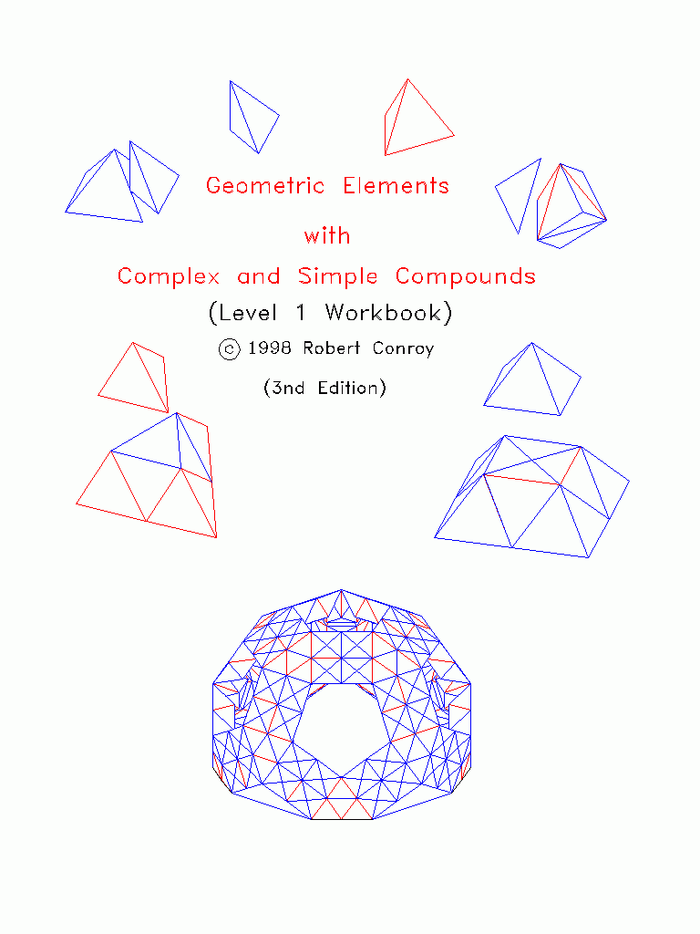
Instructions

Tools needed for construction of elements and compounds;
- Scotch tape
- Straight edge
- Good scissors
Steps in construction of elements:
- Carefully cut out shapes from cut-out pages with a good scissors.
- Carefully fold cut-out shapes with the help of a straight edge along connecting lines.
- Scotch tape figures together into forms represented by diagrams.
Individual Project
Combine the tetrahedron element with 4 octahedron elements to form a cube. Construct the other Platonic solids which are contained within this workbook.
Class Room Projects
- Combine tetrahedron elements and half octahedron compounds into double tetrahedrons and double octahedrons as shown on the cover of this workbook.
- If the class is large enough, try combining the double tetrahedrons and double octahedrons into the Tri-Pent-Rect Geodesic shown on the cover of this workbook. Geodesic connector elements are required in order to facilitate the combining of the double oct-tet compounds into a geodesic.
Printing instructions
The element cutouts should be copied onto cardstock before progressing.
