**38’ Diameter Dome**

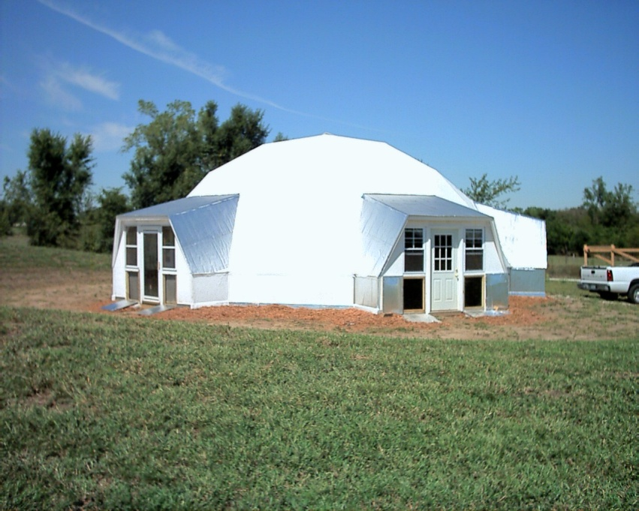

**Construction Sequence**

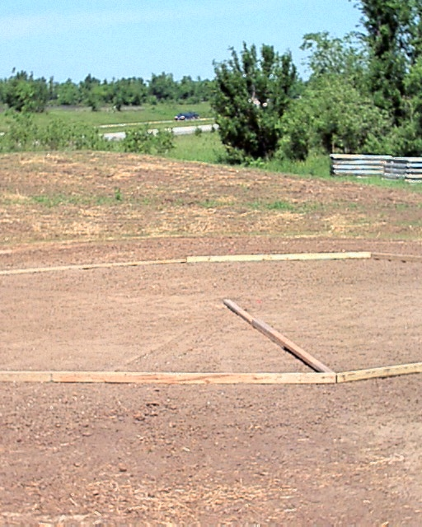

**Layout**

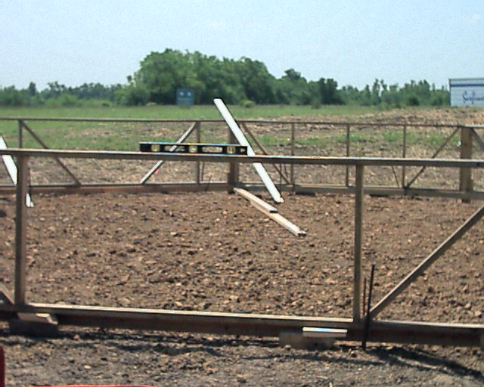

**Knee wall**

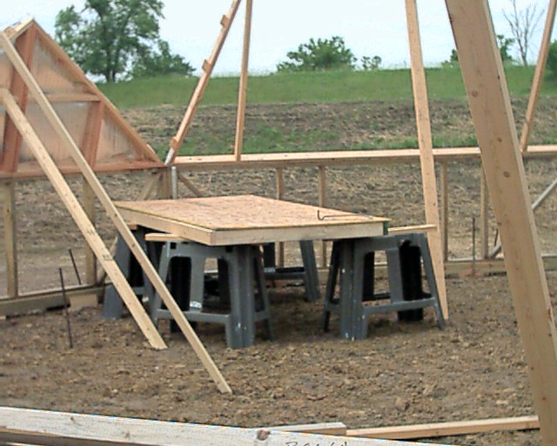

**First Level**

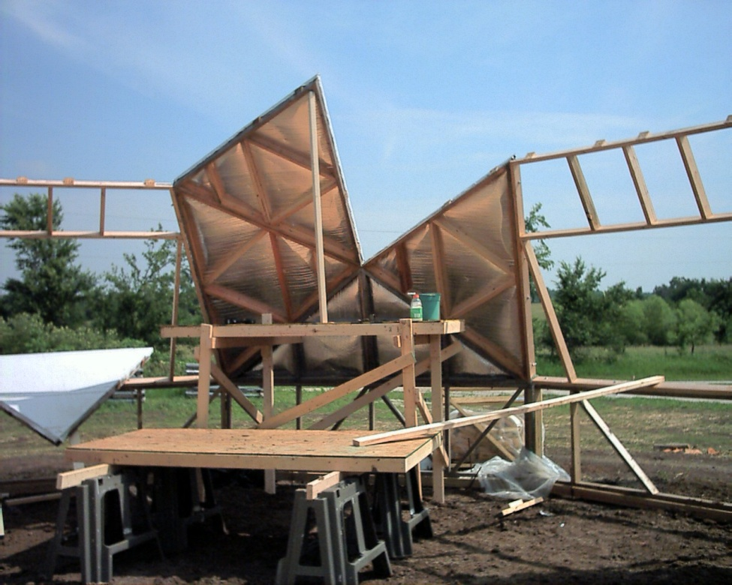

**Second Level**

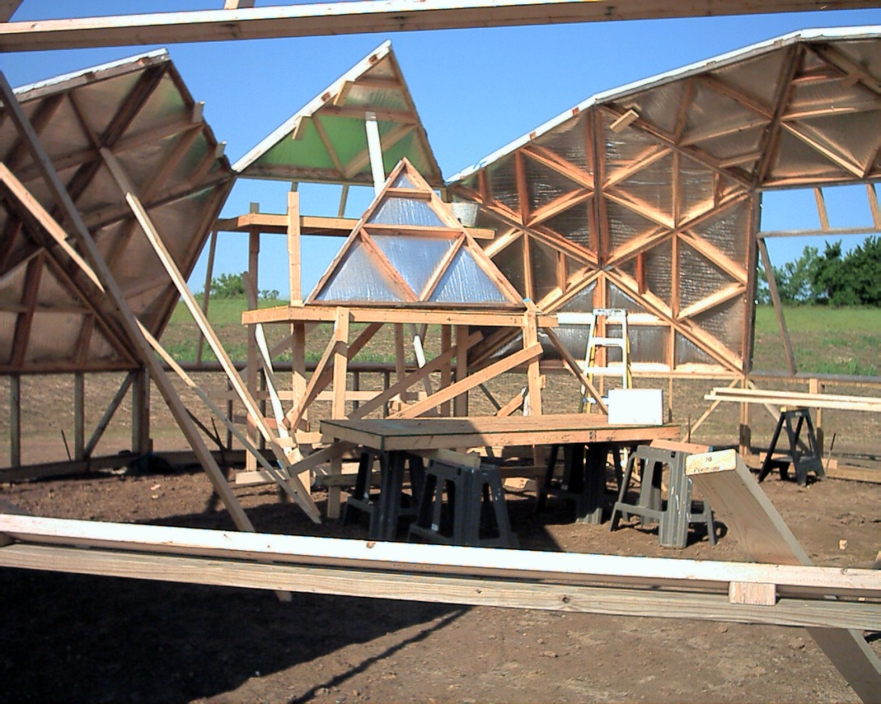

**Third Level**

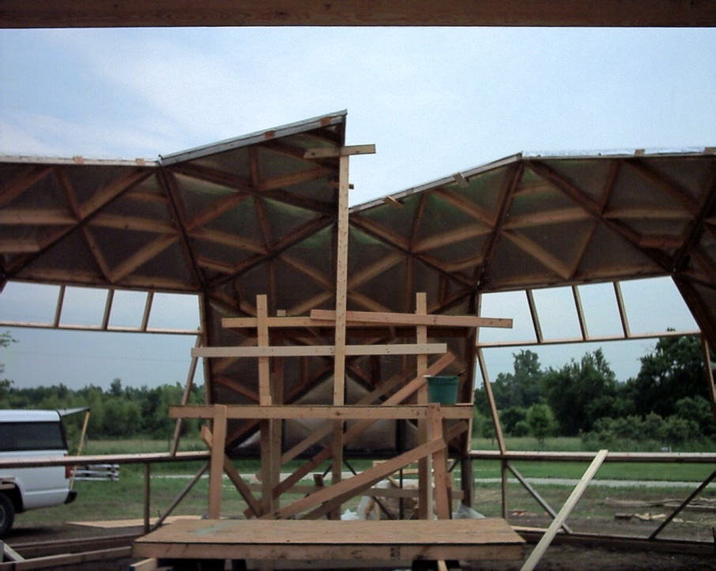

**Fourth Level**

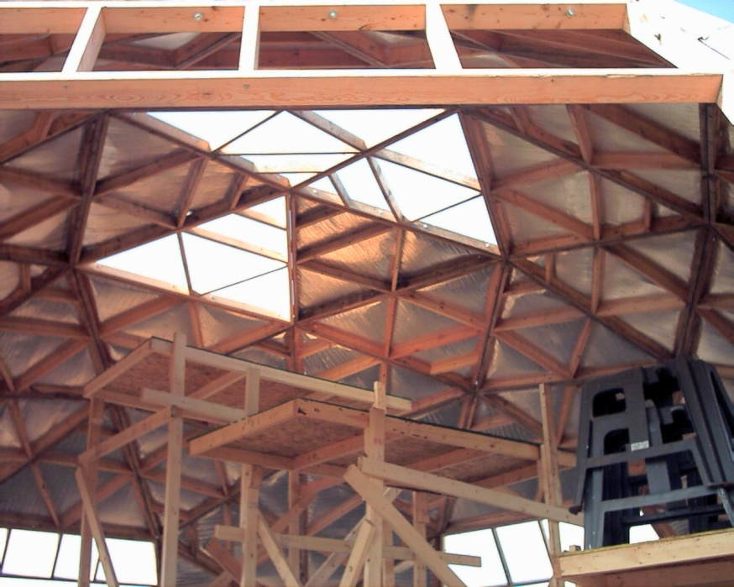

**Fifth Level**

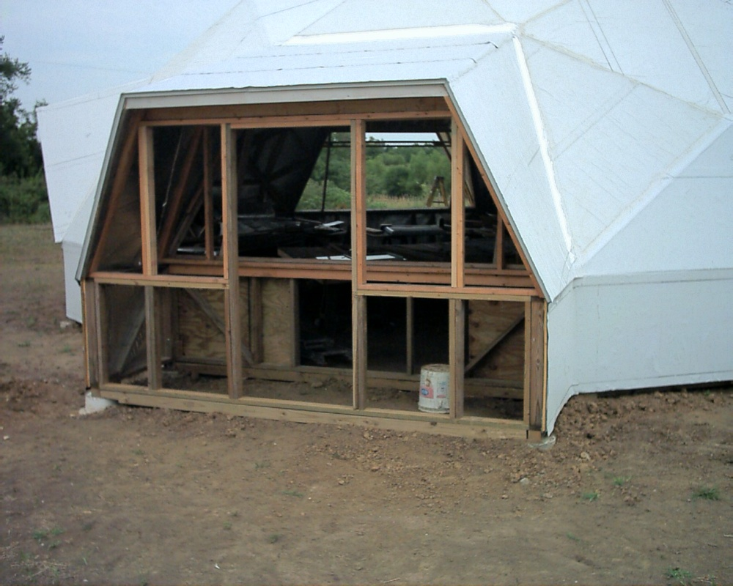

**Addition**

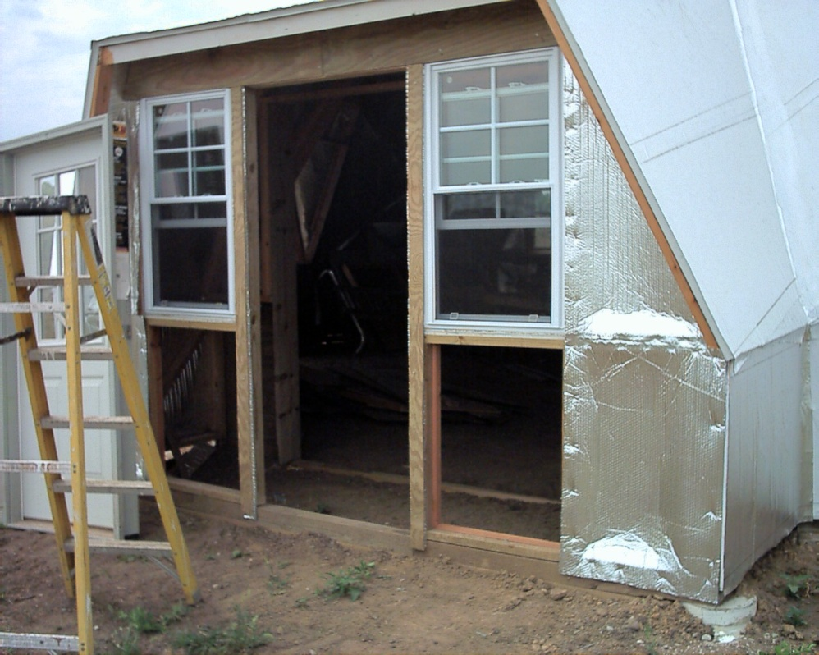

**Doorway**

**Fabrication**

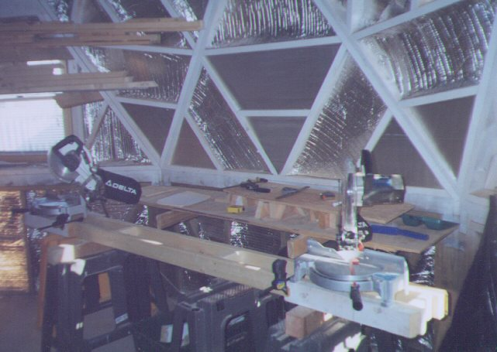

**Two saw cutting jig**

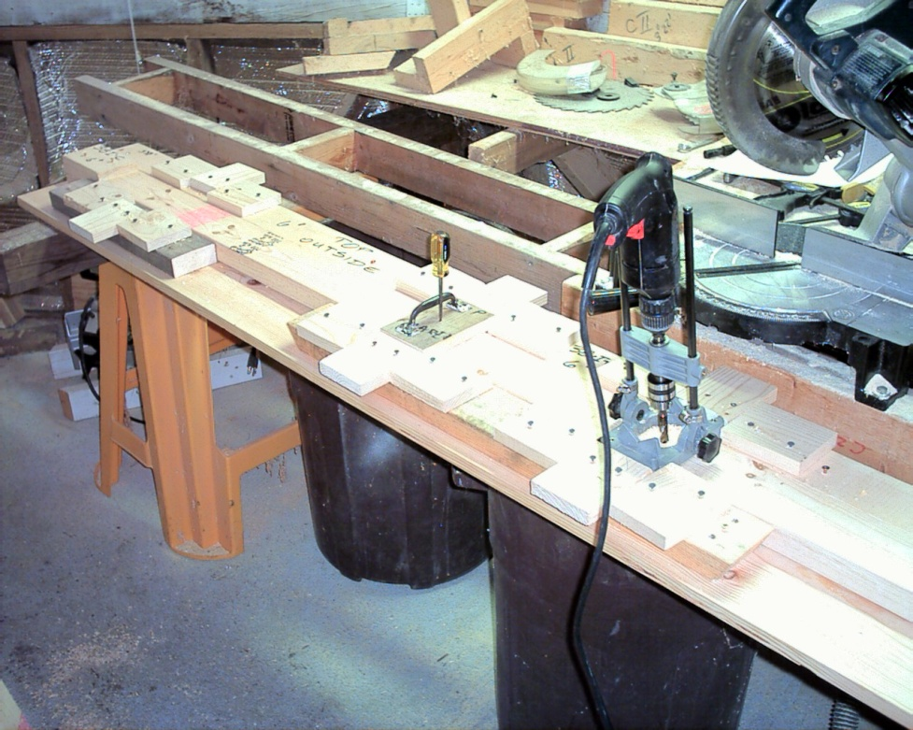

**Drill jig**

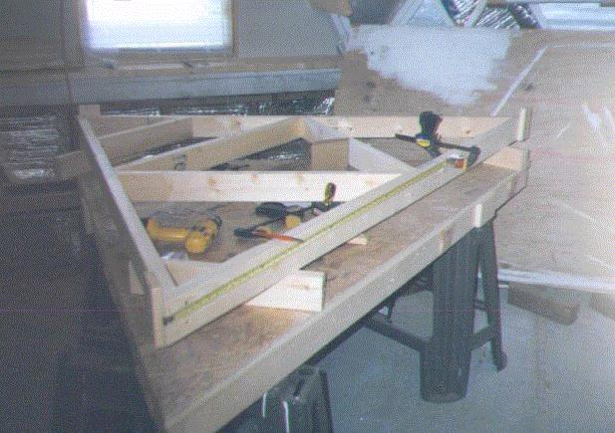

**Layup Jig**

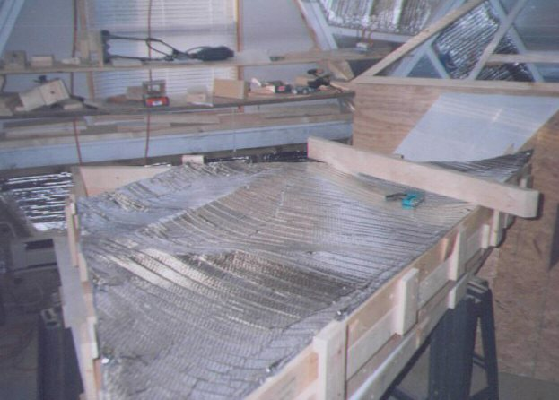

**Reflex Insulation installation**

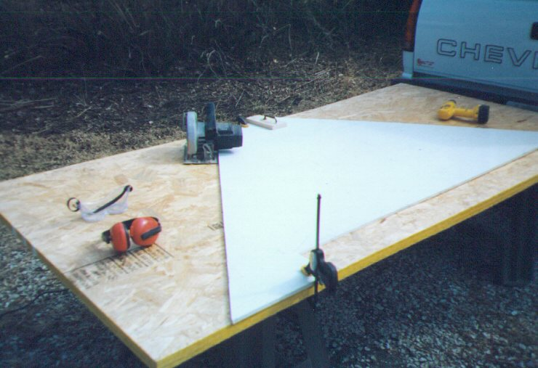

**Pattern for cutting sheathing and board insulation**

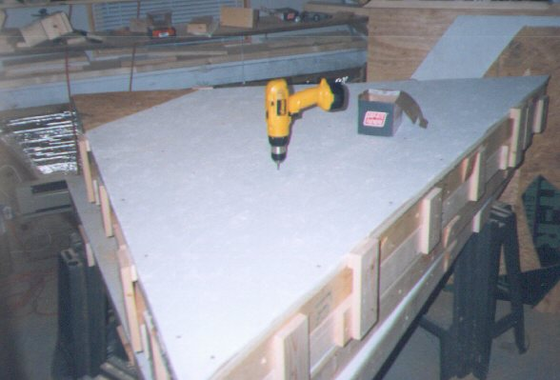

**Sheathing insulation**

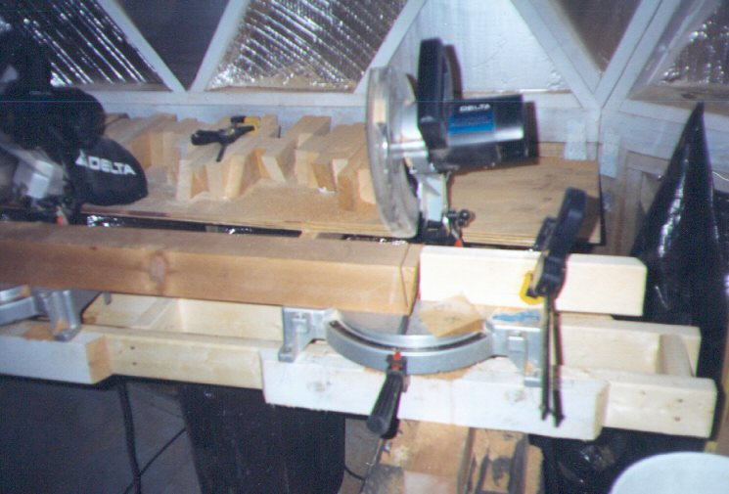

**Jig for cutting wedge connectors**

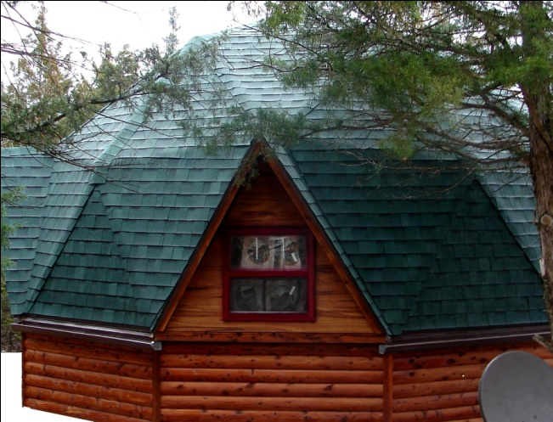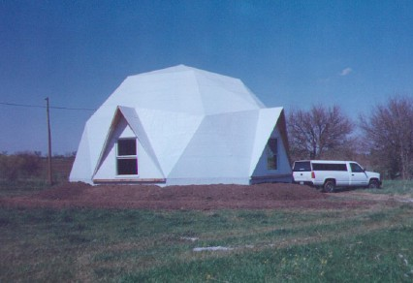

**24’ Dome 32’ Dome**

**Book cost:**

**38” fabrication and assembly book: $250**

**32’ fabrication and assembly book: $120**

**24’ fabrication and assembly book: $100**

**Send check to: Mountain Truss Corporation**

**312 East 79th Street**

**Kansas City, Missouri 64114**