Premium Compressed Earth Blocks
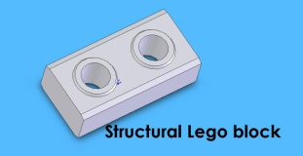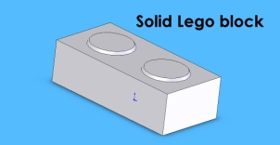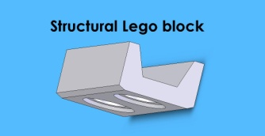

Block inserts required
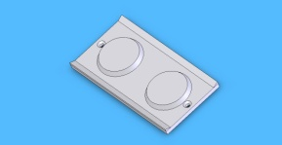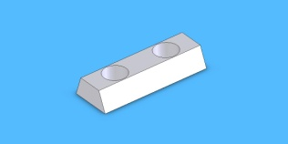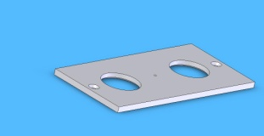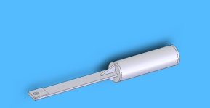

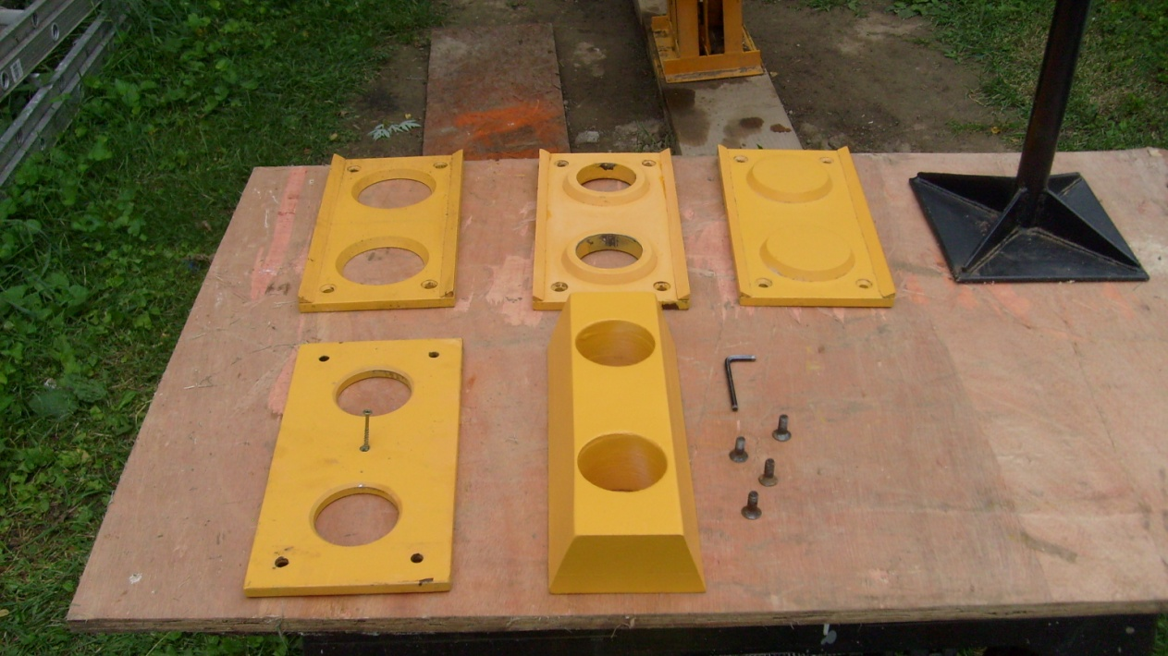
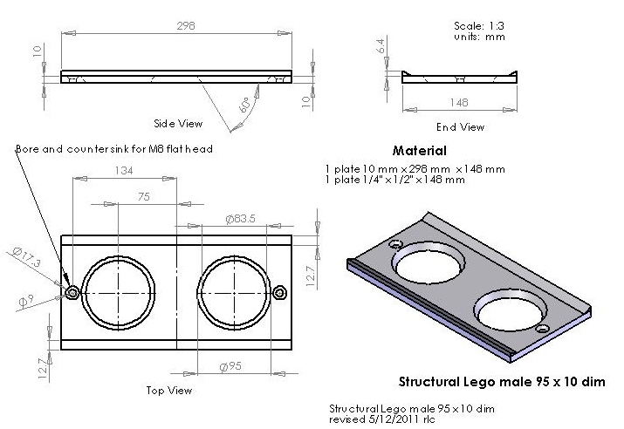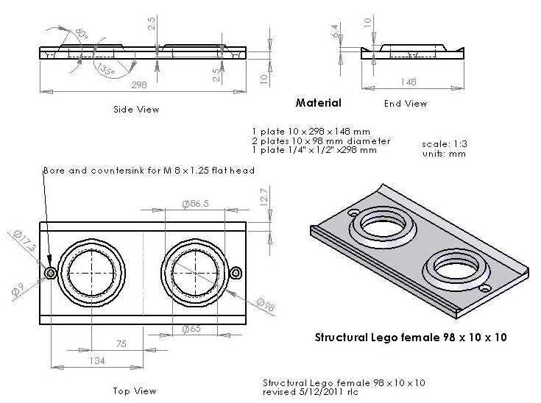
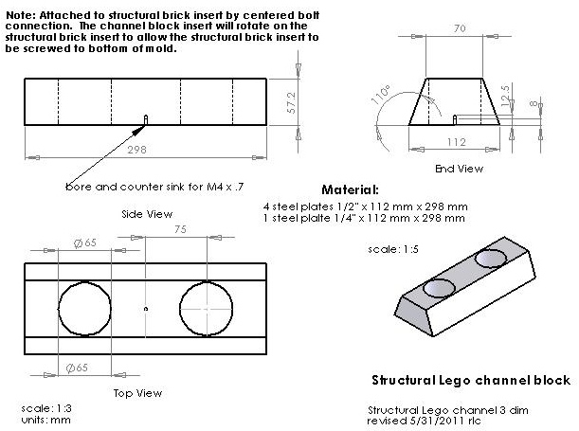
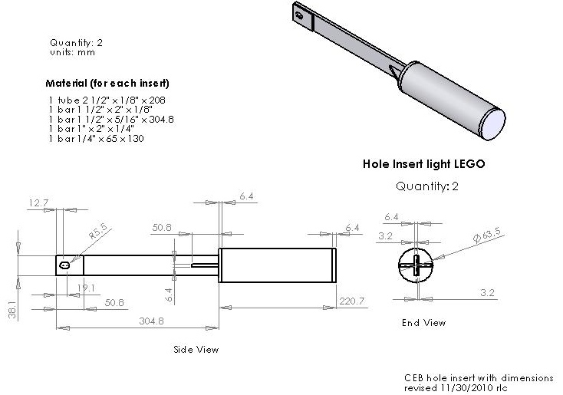
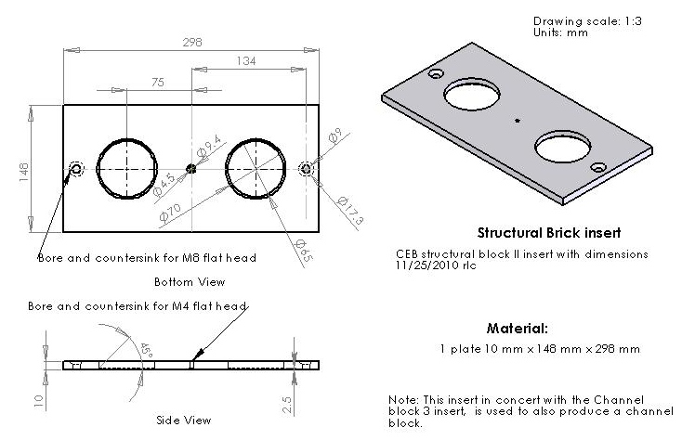

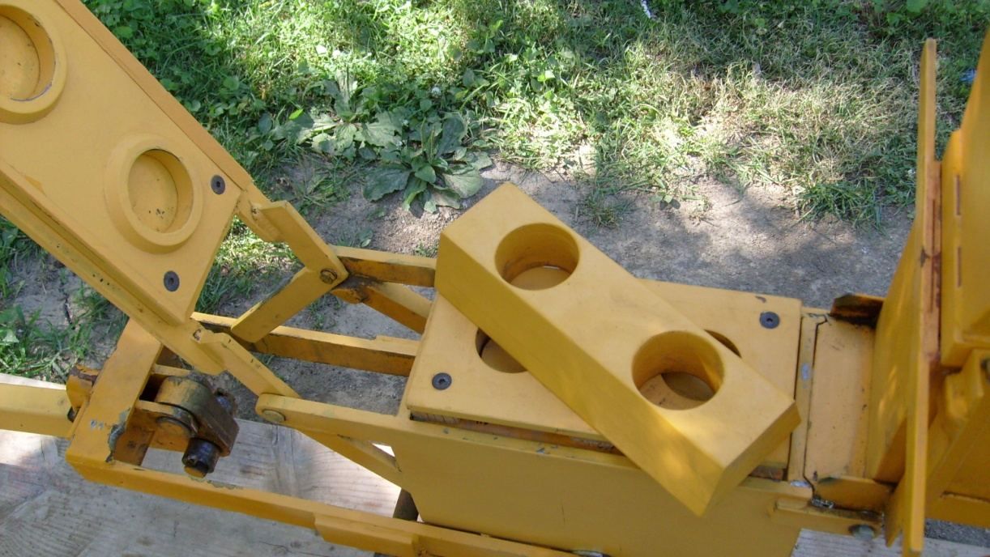
Structural Lego Channel block set up
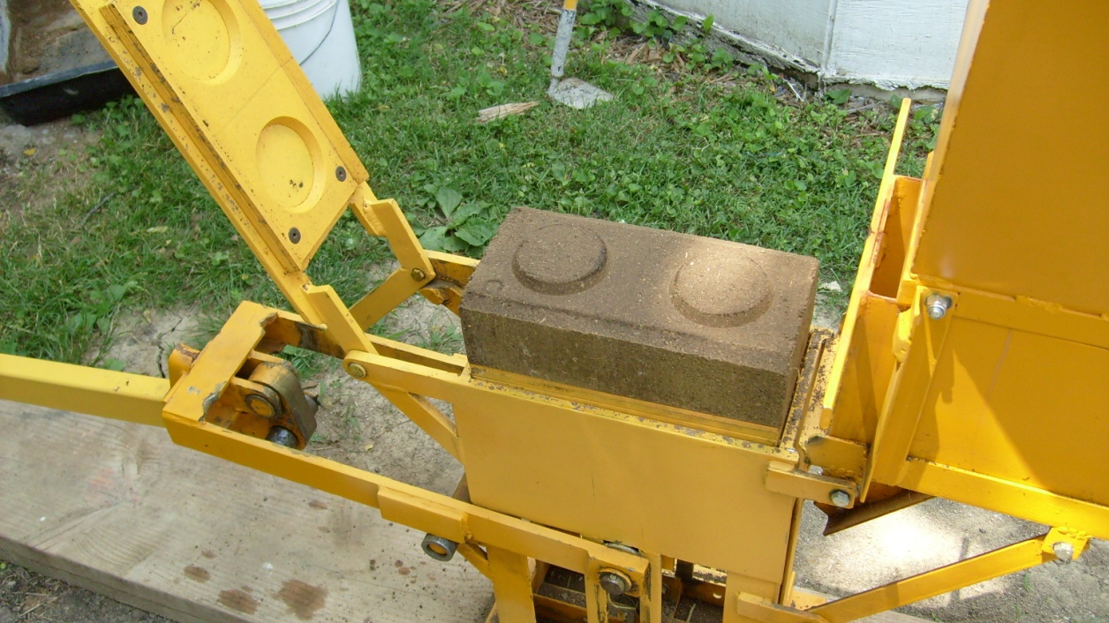
Solid Lego Block
http://www.youtube.com/watch?v=xLiu4BkHQKc
(mixing water/soil)
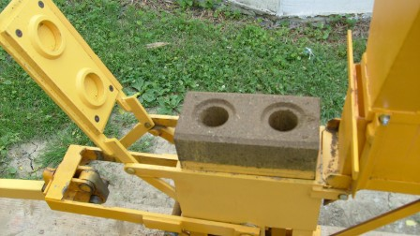
Structural Lego block
http://www.youtube.com/watch?v=udmJqbx1Yb8

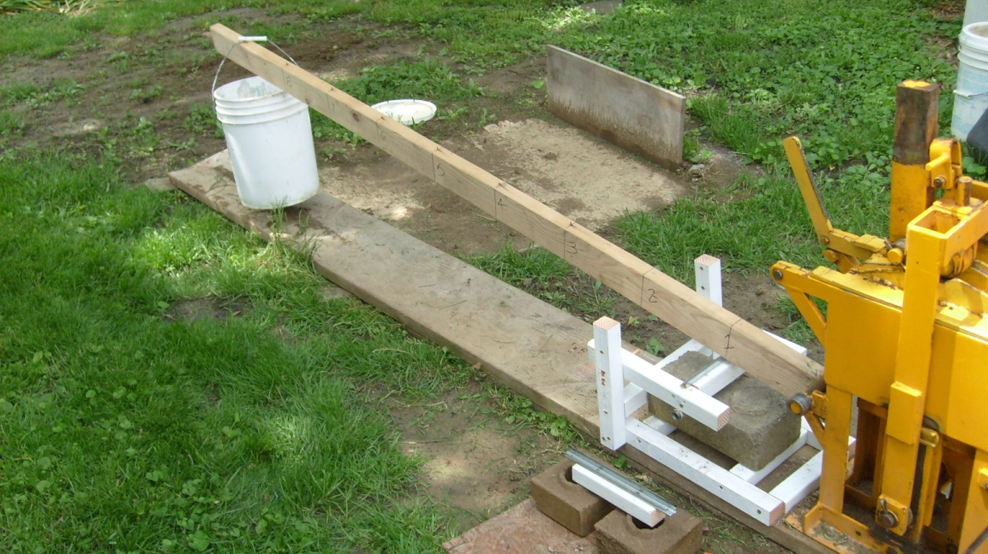
Bending test using reversed block cutter
http://www.youtube.com/watch?v=Rq4LWZMGjiU&feature=c4-overview&list=UUmKF-r1ensXdyDsyxJ2Nqug

http://www.youtube.com/watch?v=QeVqM3gcntA
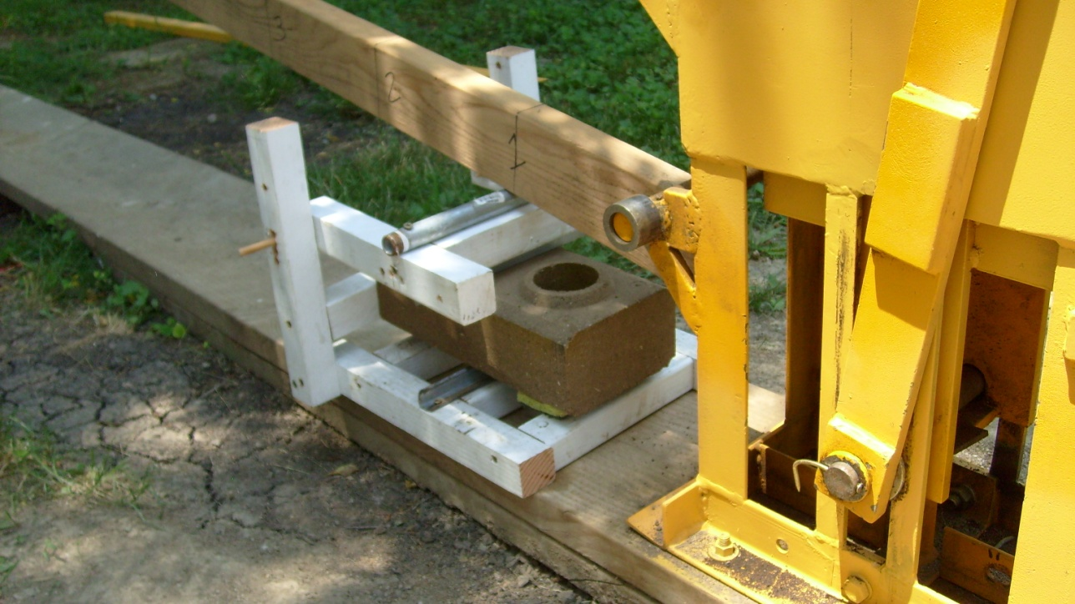
Setup for cutting CEB block
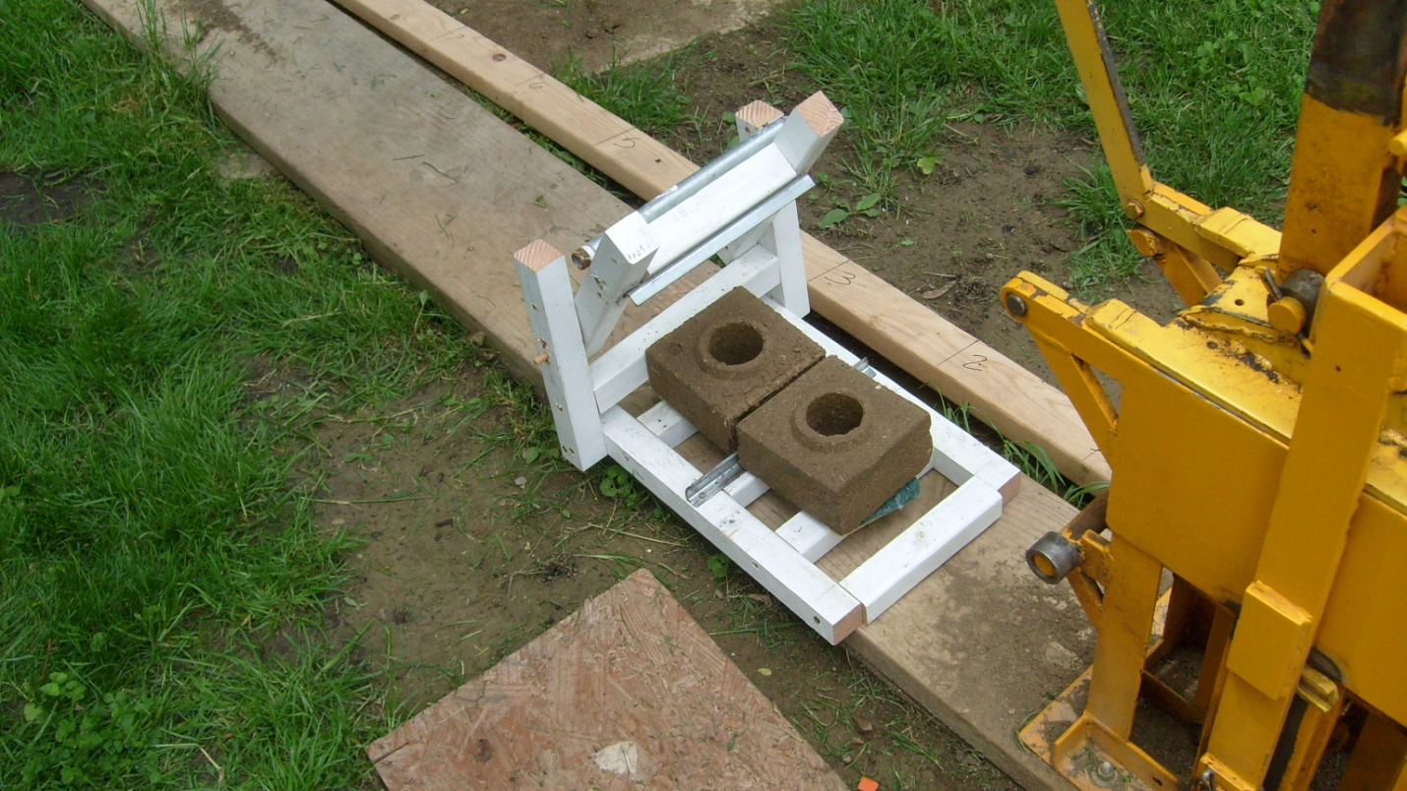
Cut block
http://www.youtube.com/watch?v=Ndz2Sm1pcAw
Slurry wall construction
http://www.youtube.com/watch?v=8rPmYA3RO84
Slurry construction is a simple, non skilled method of constructing block housing.
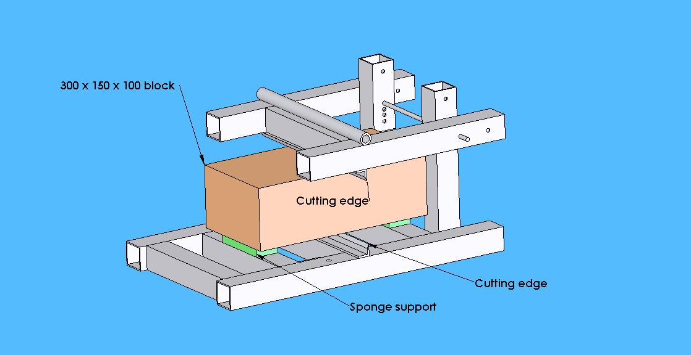
Drawing of block cutting and testing jig

