Dome Books & kits

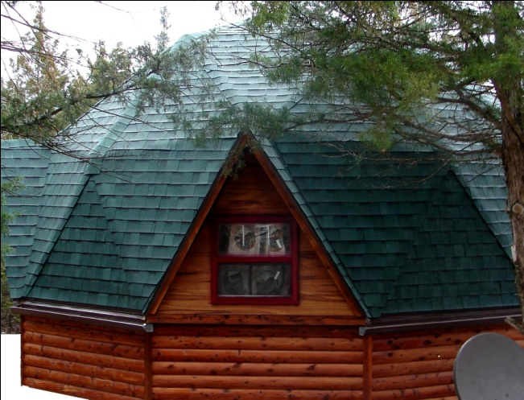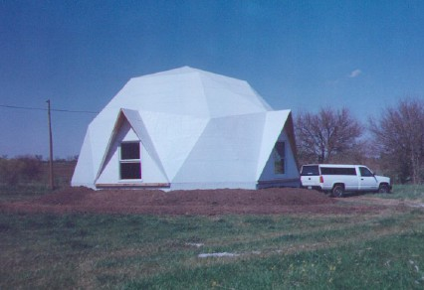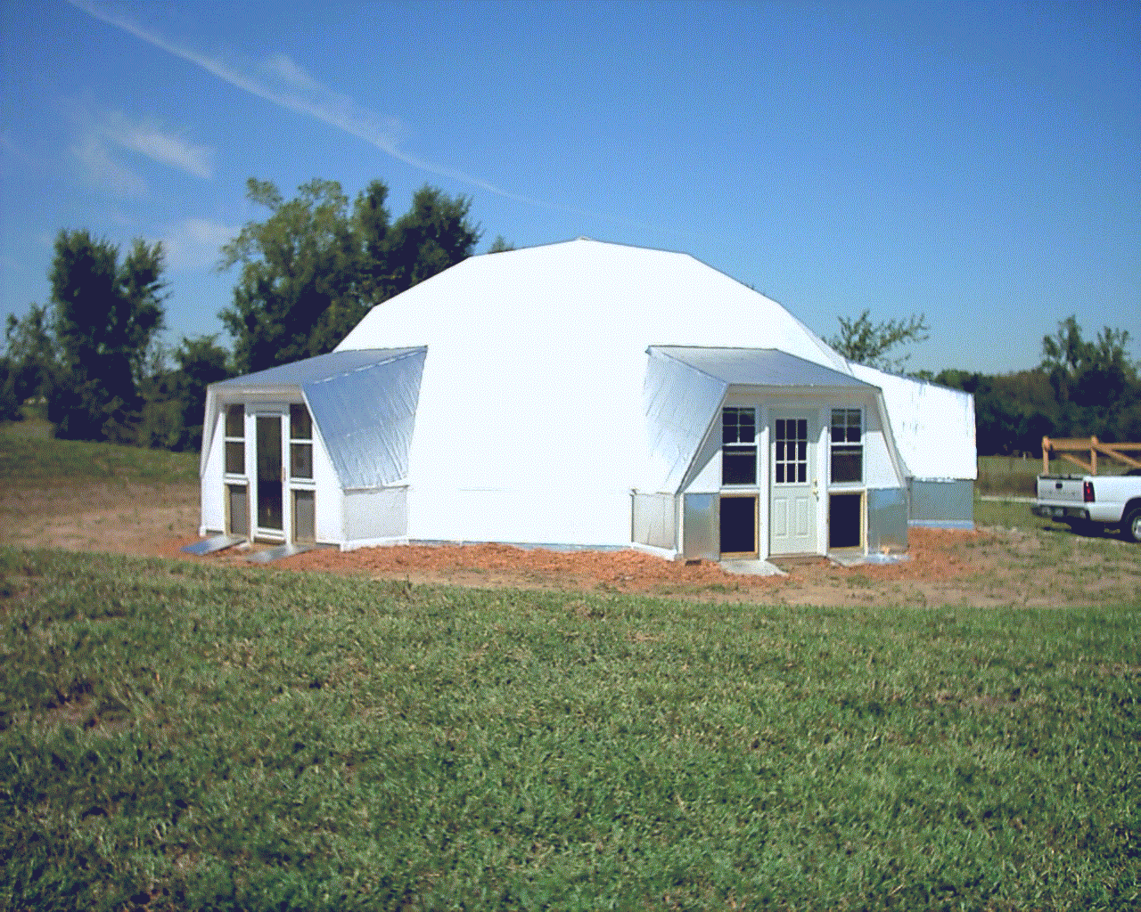
24’ Dome 32’ Dome 36’ Dome
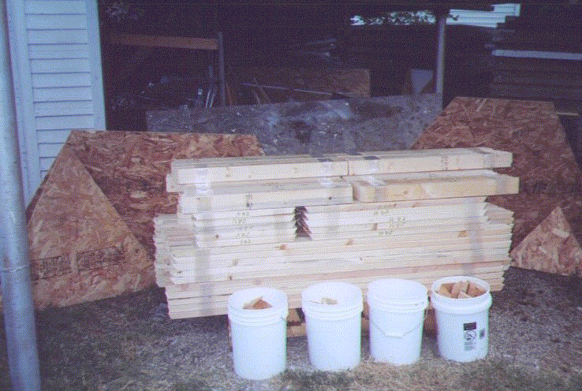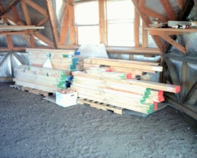
24’ Dome kit (on sale for $2500) 36’ Dome kit (on sale for $5000)
(Kits include cut and drilled 2x4s, wedge connectors, & patterns for sheathing and insulation)
Book cost, less postage:
38” fabrication and assembly book:
32’ fabrication and assembly book: $120
32’ second floor fabrication book: $80
24’ fabrication and assembly book: $100
24’ second floor fabrication book: $80
Send check to: Mountain Truss Corporation
312 East 79th Street
Kansas City, Missouri 64114

