Nature’s 3D Geometrical Structural Elements
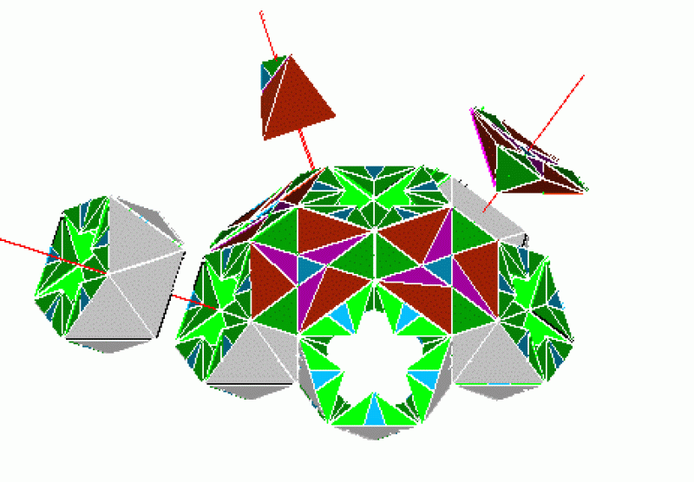
Golden Mean Hex/Pent Solid
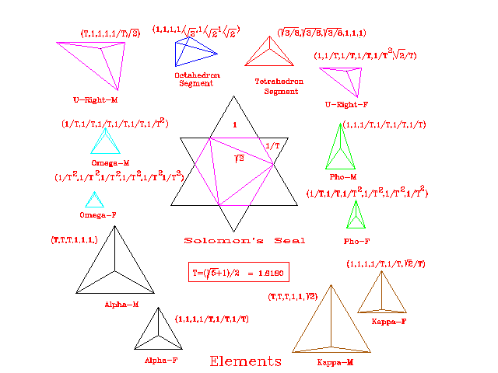
Primary Platonic Geometric Fibonacci based Elements
Plato’s definition of elements: The simplest solid would be a pyramid that consists of four triangular surfaces. Golden Mean (Tau): http://freemasonry.bcy.ca/symbolism/golden_ratio/index.html
Nature’s elemental geometry is used in the geometry of everything, ranging from the ocean’s small radiolarian, to the shape of our Galaxy.
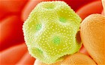 Pollen 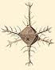 plankton 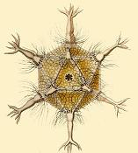 Radiolarian

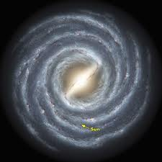 Spiral shape of our Galaxy 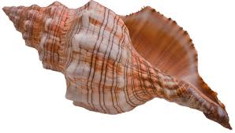
Conch Shell Spiral
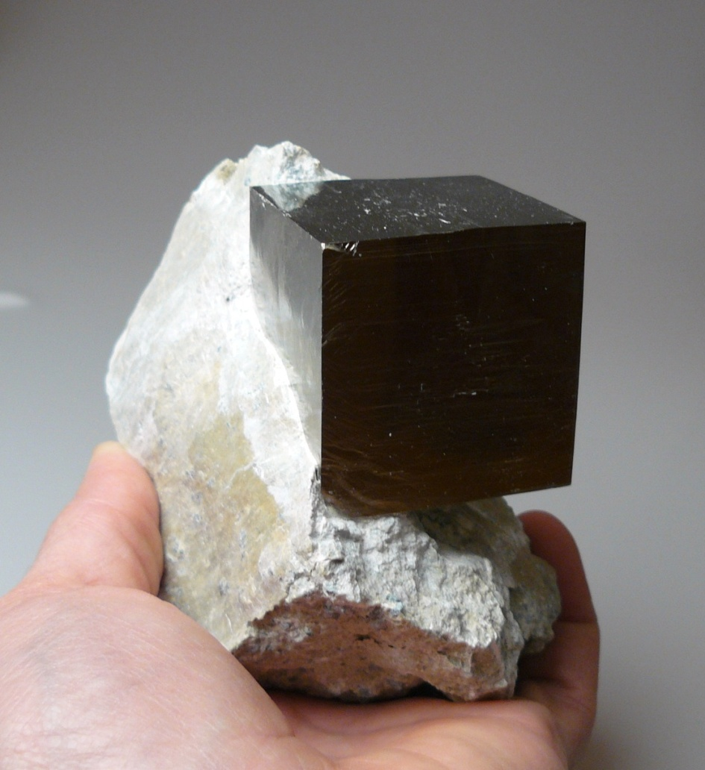

Natural occurring cubic pyrite

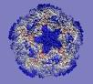
Avian Flu Virus
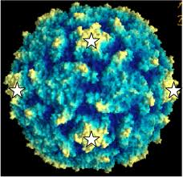
UCLA Virus
These viruses are very similar to that of the Golden Mean Hex/Pent Solid

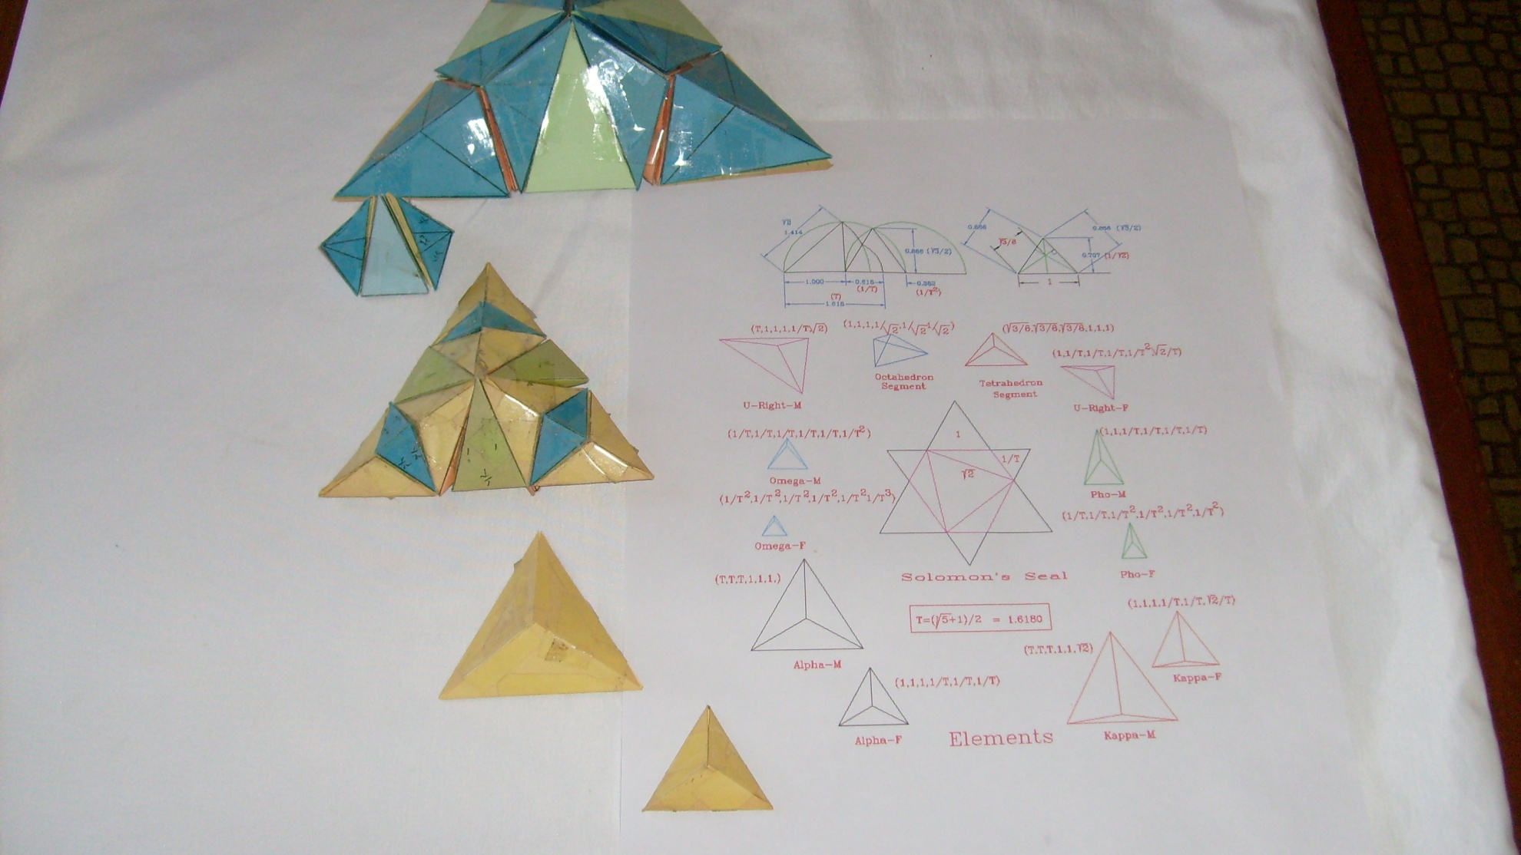

Alpha male/female Elements and Fibonacci progressions

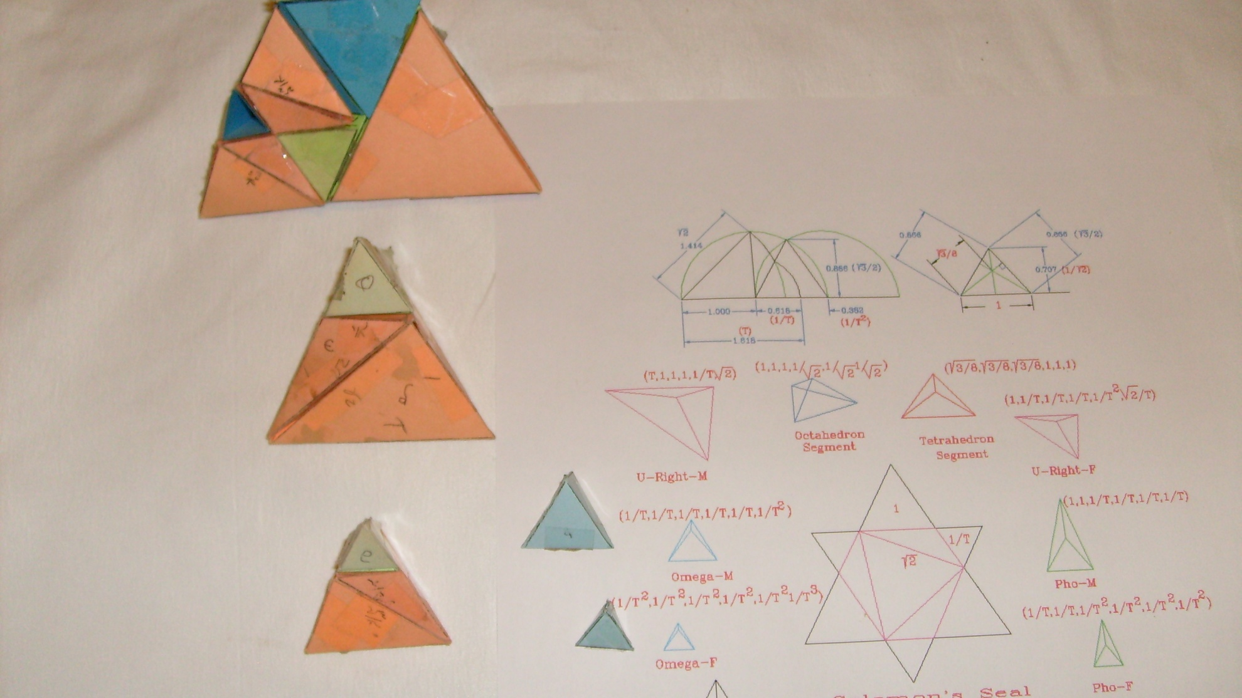
Omega male and female elements with Fibonacci progressions
based on the assimilation of other Platonic elements
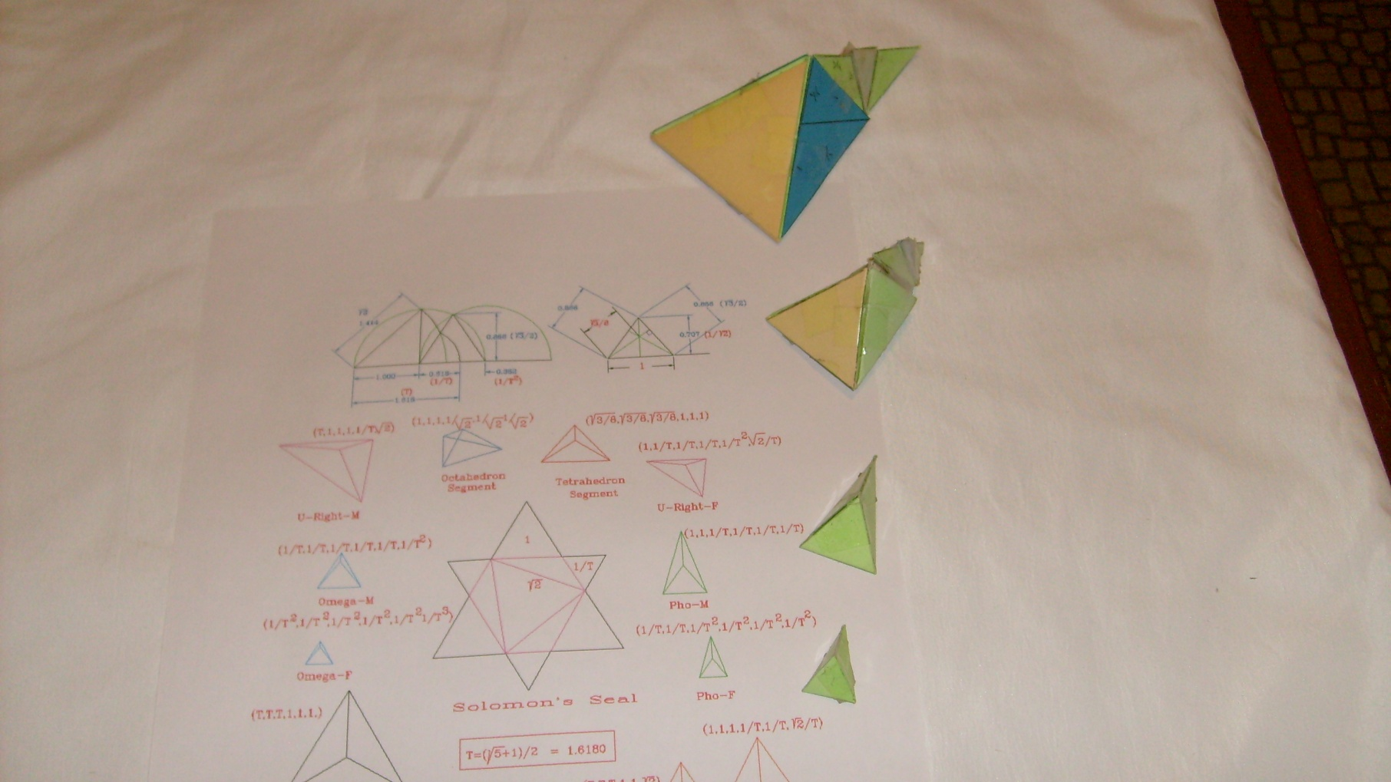
Pho male and female elements and their Fibonacci progressions

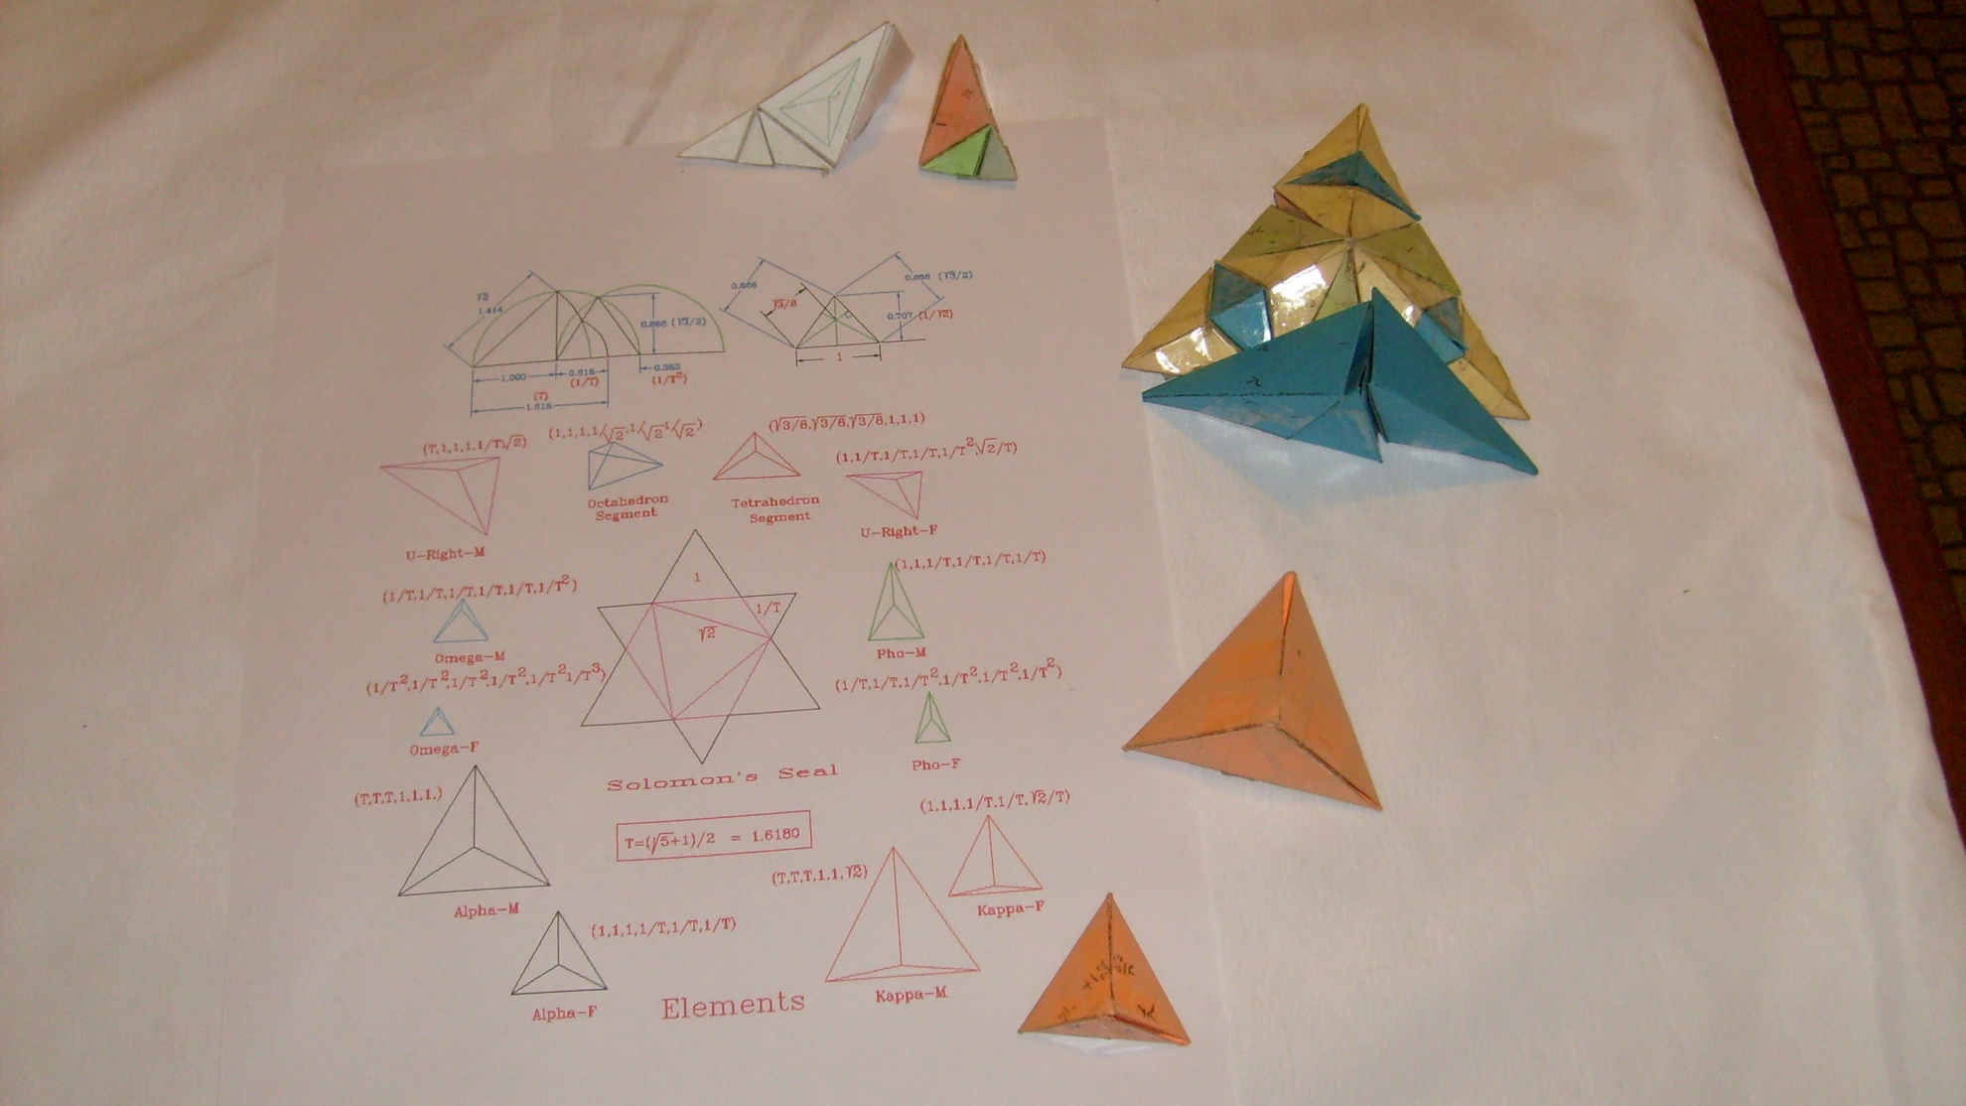
Kappa male and female elements plus their Fibonacci progressions
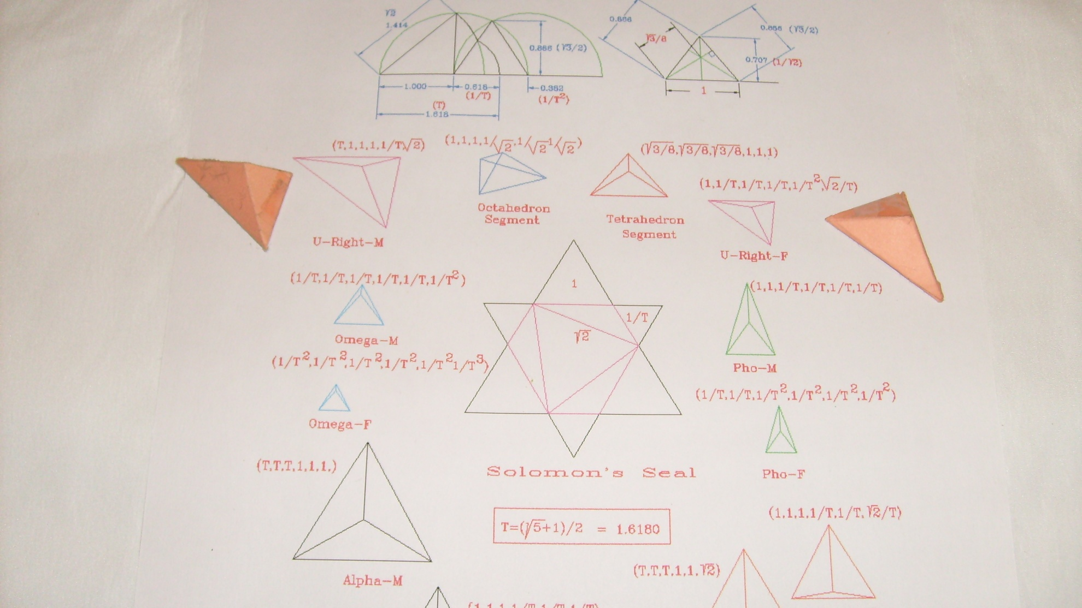
Unbalanced right & left elements (Octahedron derived from Isocahedron)

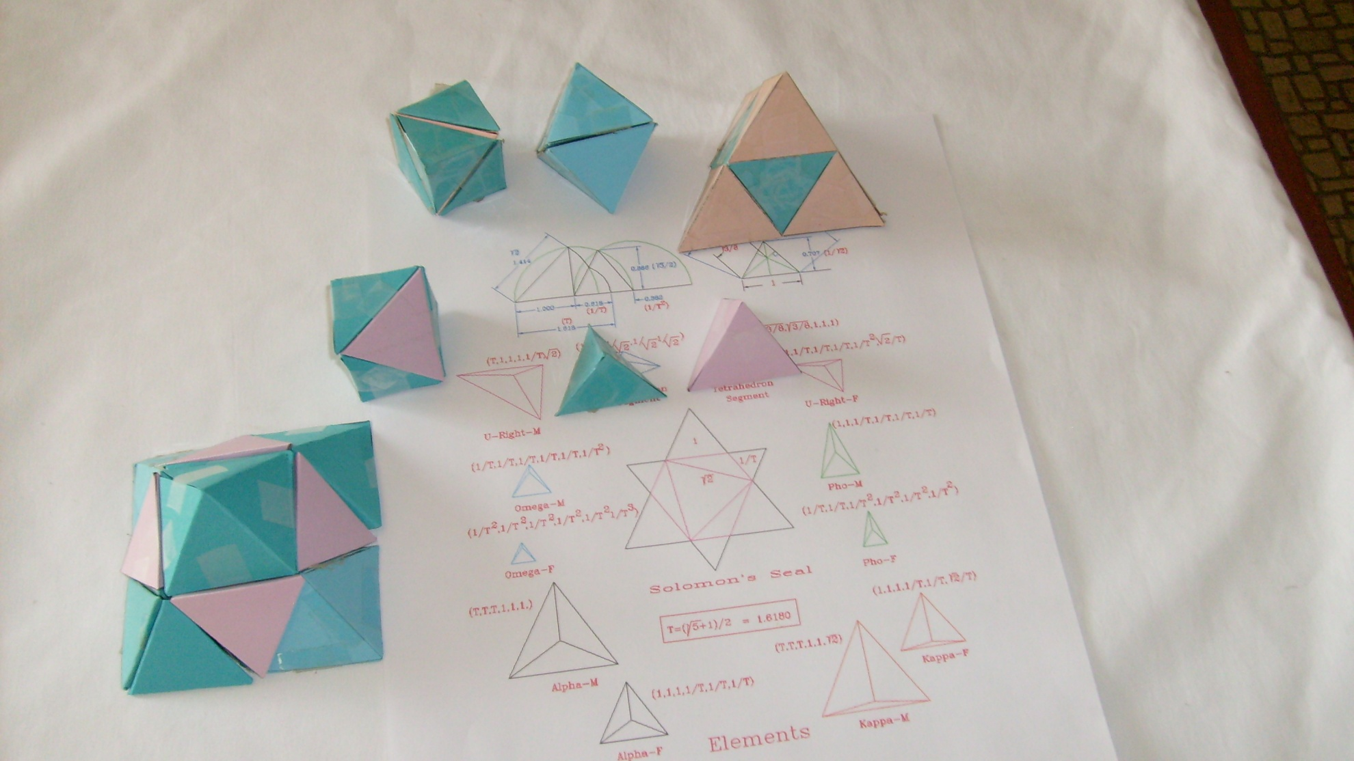

Traditional Tetrahedron, Octahedron, and Cube construction and unit progressions

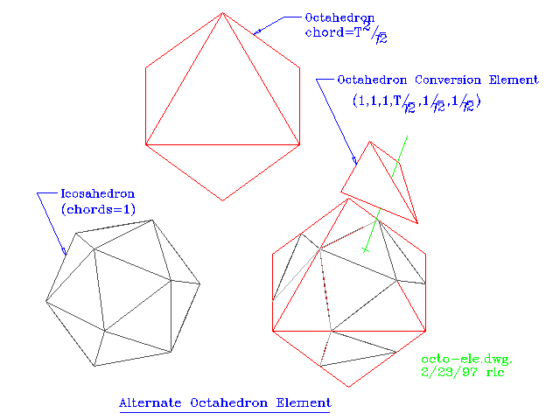
Alternate Octagon construction
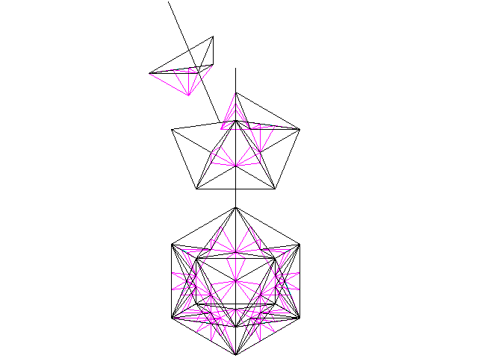
Structural Elment based Icosahedron
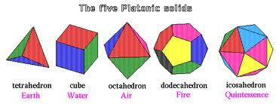
Platonic Solids

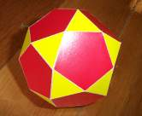
Archimedean Solid
(Icosidodecahedron)

Note: For molecular modeling, he icosidodecahedron can be used as the base of all of the Platonic Solids
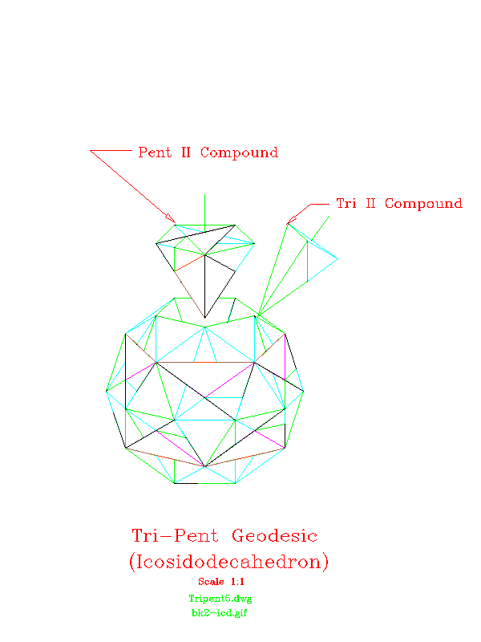
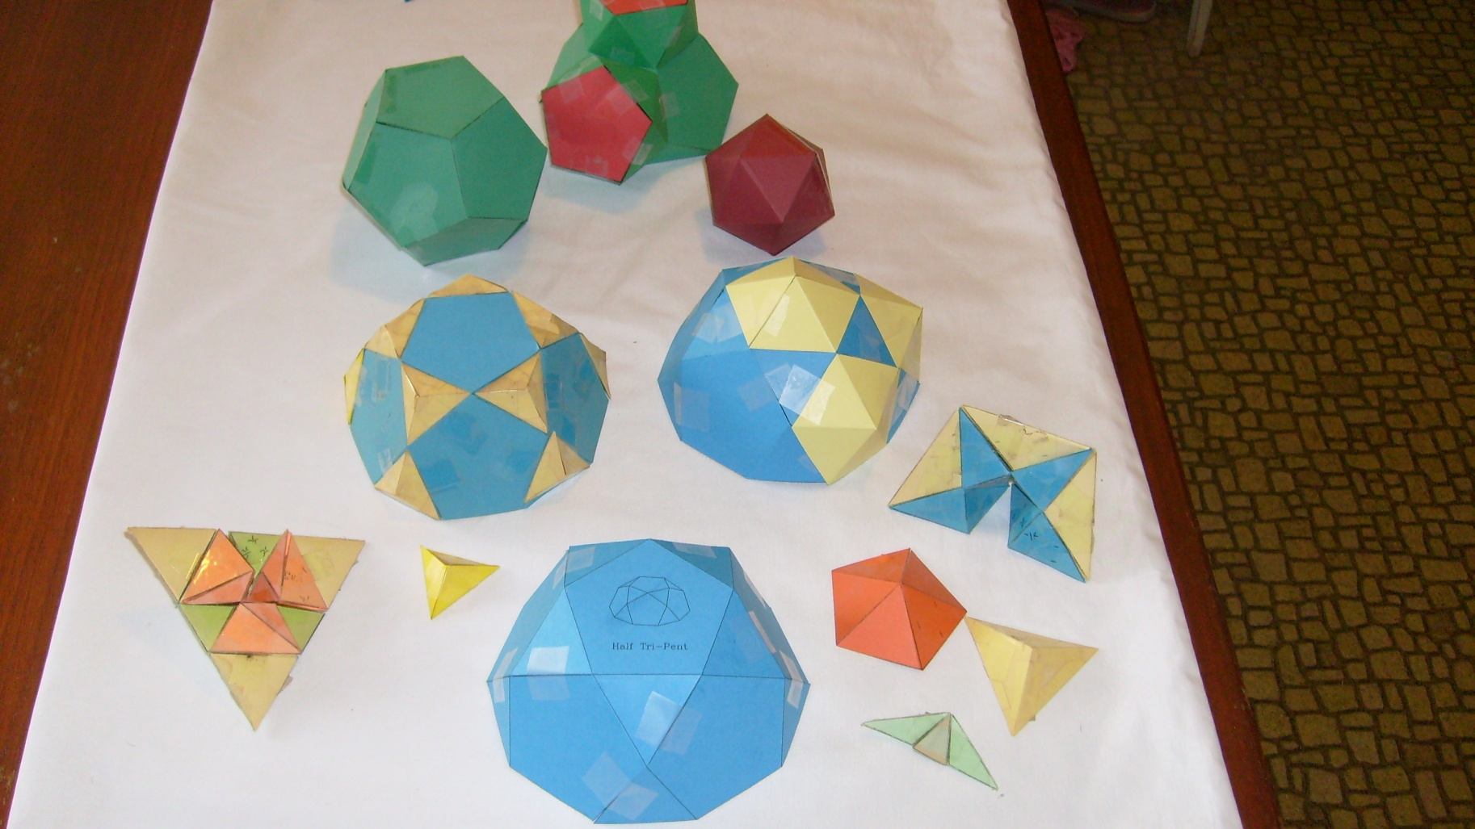
One method of Dodecahedron and Icosahedrons construction is to use the Icosidodecahedron (Tri-Pent) solid for the base. The Tri-Pent solid can be constructed from the Fibonacci elements. With the addition of elements or compounds composed of Fibonacci elements, the Tri-Pent Solid can be converted into a Dodecahedron or Icosahedron Solid.
The Hex-Pent Solid is derived from a base Dodecahedron plus 12 truncated Icosahedrons, 12 Wedge Compounds, and 12 Solid Hexagon compounds.
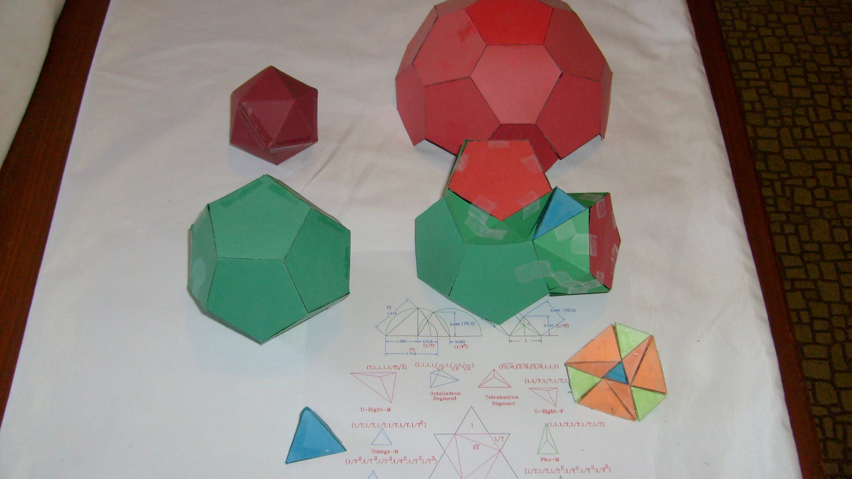
Hex-Pent is built from dodecahedron base, 12 truncated Icosahedrons, 12 wedge compounds, and 12 Hexagon solid compounds
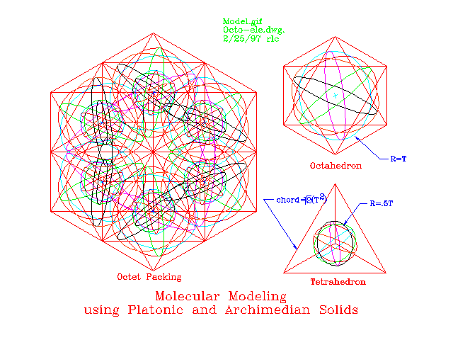
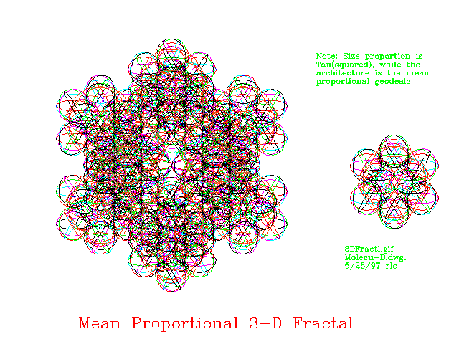
3D Fractal Modeling of Platonic elements
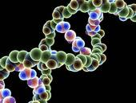
DNA helix
(the packing of basic Platonic solids and their Fibonacci compounds)
Geometry: http://www.youtube.com/watch?v=pN4HxbDm8Rw&list=UUZoE8XUs4AOlf65drmm6iVA&feature=player_detailpage

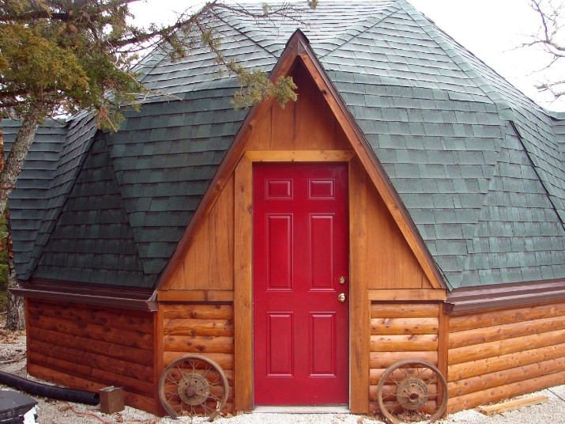
Useful application of Archimedean Solid (Tri-Pent Solid)
References on Fibonacci: http://www.goldennumber.net/spirals/
http://www.maths.surrey.ac.uk/hosted-sites/R.Knott/Fibonacci/fibnat.html
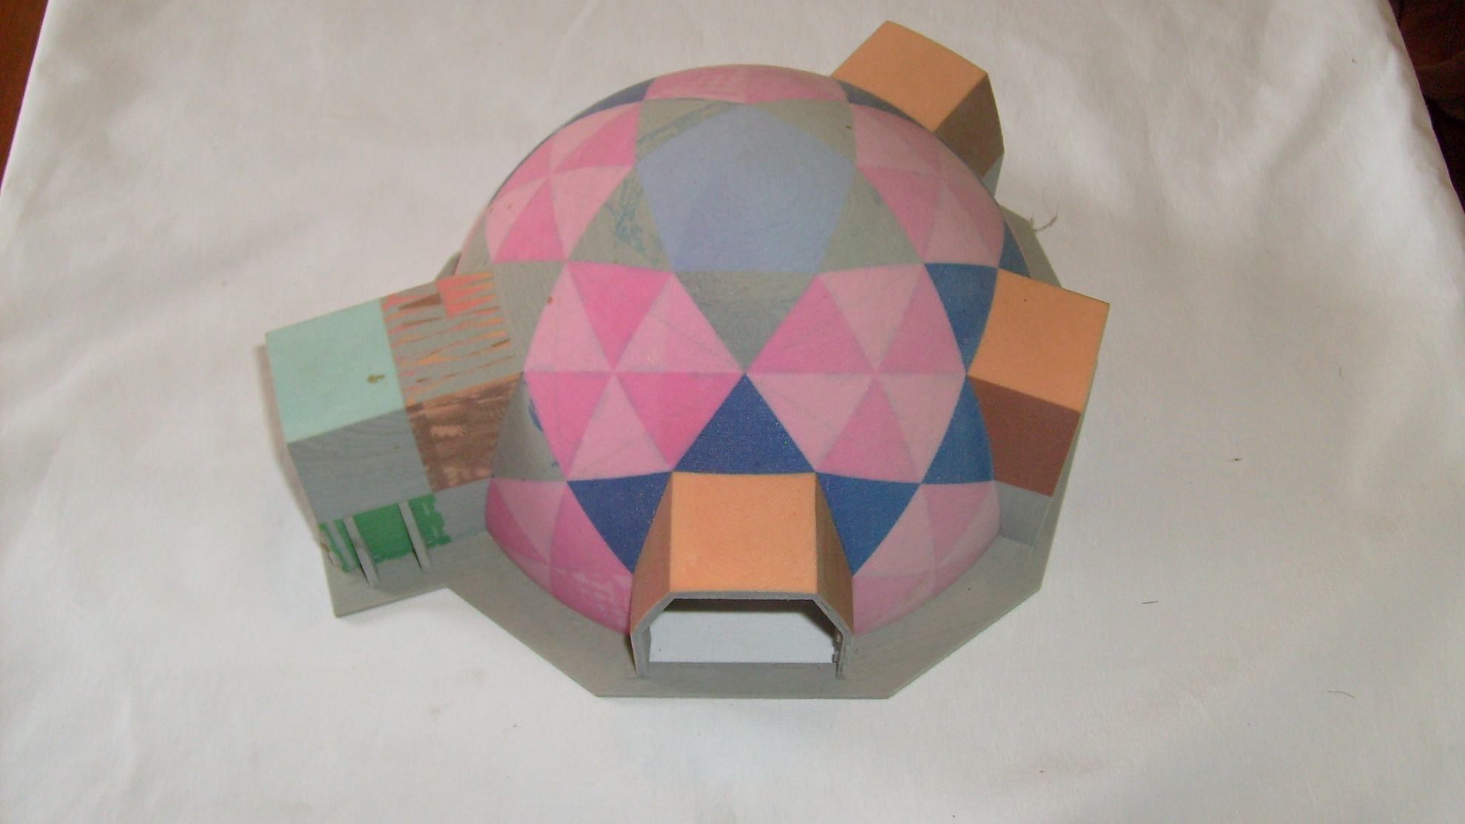
Hex-Pent model of low cost paneled dome home

Hypothesis
The imagery used in compiling the 12 basic Fibonacci elements came from the Old Testament description of Israel. This description of Israel being based on the 3 basic fathers, being Abraham, Isaac, and Jacob, standing in as the basic lengths of unity, square root of two, and Tau. The 12 basic elements being in line with the 12 sons of Jacob. The first two elements, having a different form consistent with the sons of Jacob’s first wife versus the other 10 sons of his other wives.
Just as Isaac Newton, one of the premier, or the premier scientist of all time, used the bible in his search for the answers for scientific questions, I believe that his source of inspiration has not been fully developed. I believe that not only can this type of endeavor achieve better housing, but better sources of energy.
To use this architecture, on which to base an energy resource, one needs a competing architecture with a different energy potential. This could be developed by using the imagery of Jacob and Ishmael, and their respective 12 sons. It would be similar to tapping the energy between matter and anti-matter.
Another avenue of energy research could be in the realm of Plato’s commentary on Atlantis, and the relationship with the Atlantean power crystal. Being that energy is a vibrational entity, which is based on distance and time, and that crystals can transmute captured energy, and possibly through the use of vibrational resonance, and sympathetic harmony, capture untapped frequencies of energy. Similar to how Edgar Cayce’s referenced use of the“Firestones” of Atlantis.
This would be somewhat in the realm of the use of the structural geometry of quartz to capture sunlight and change it into energy, but instead using untapped sources of energy and structure to capture that energy.

