**Setting 22’ Diameter Dome piers**

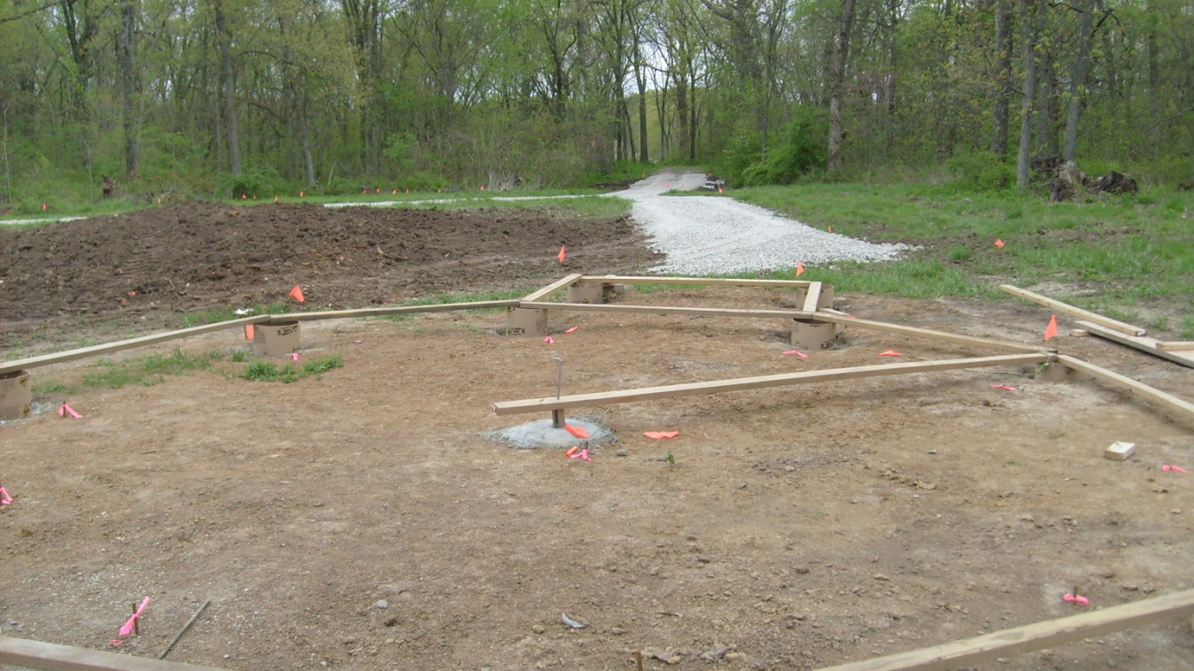

Layout pier points, dig, and set pier forms

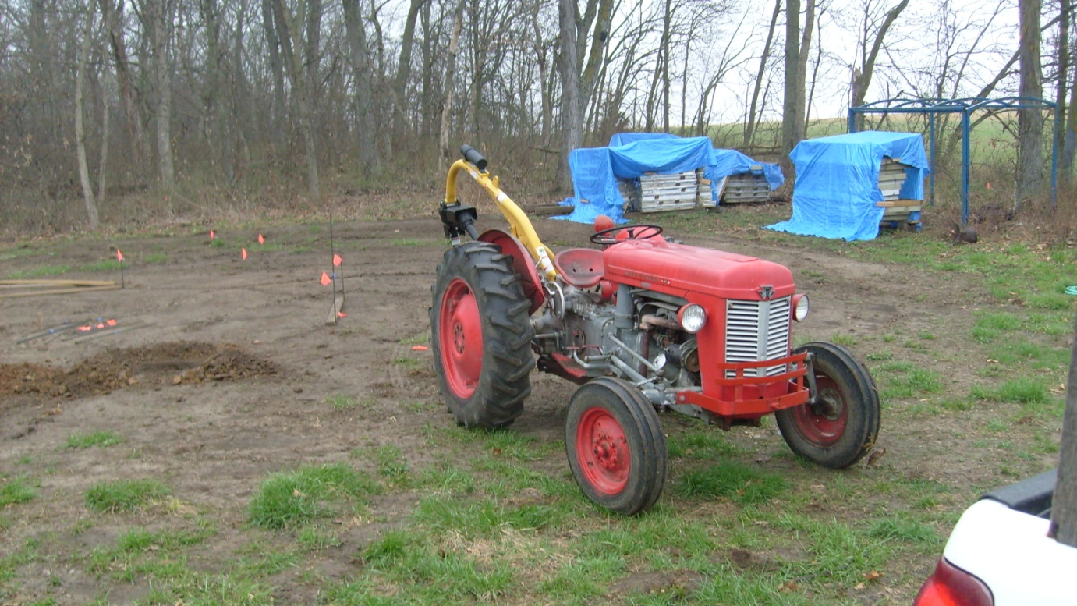

Digging of pier holes

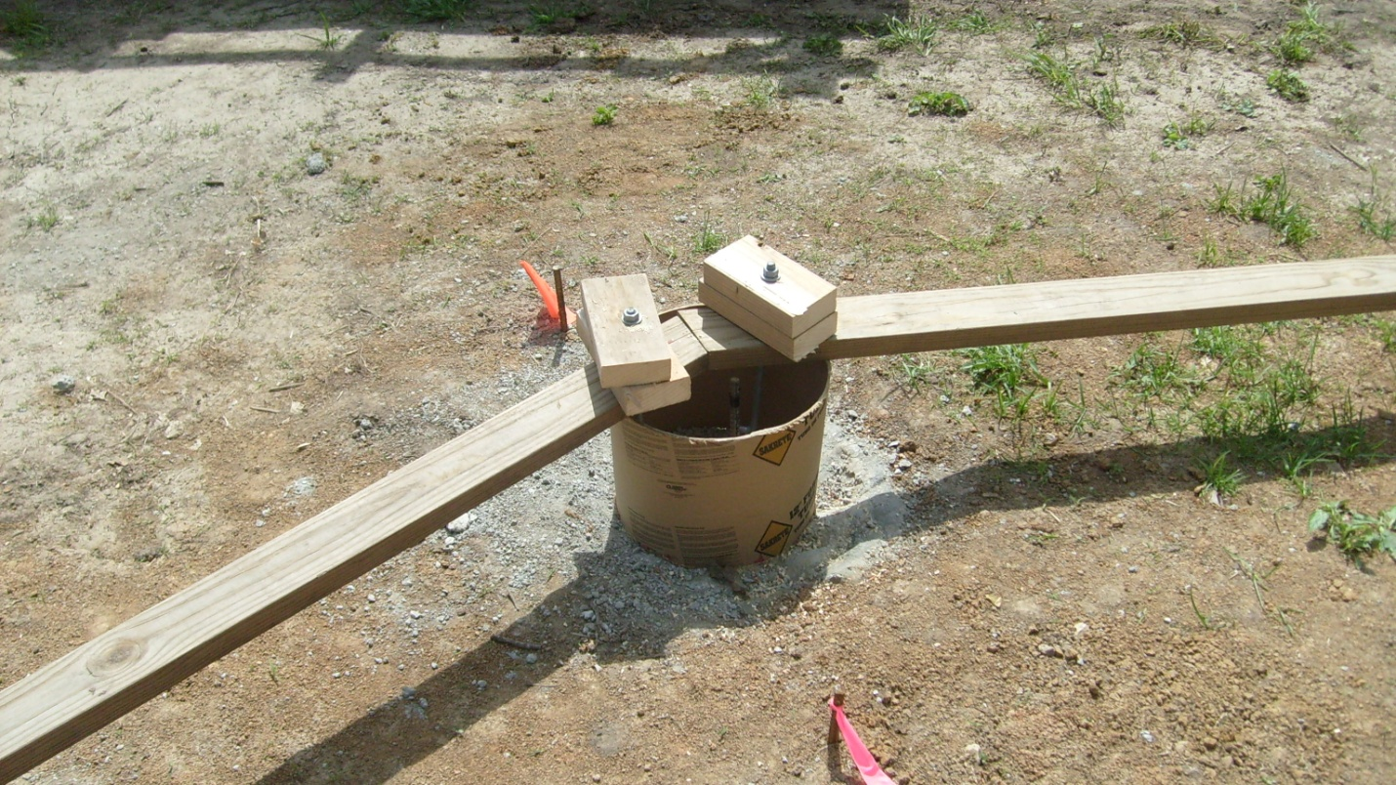

Set anchor bolts

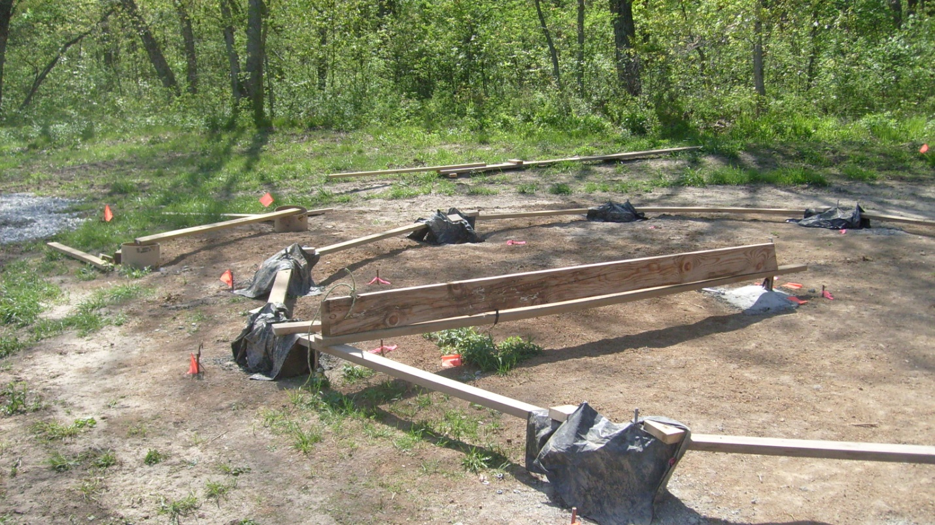

Pour concrete and cure

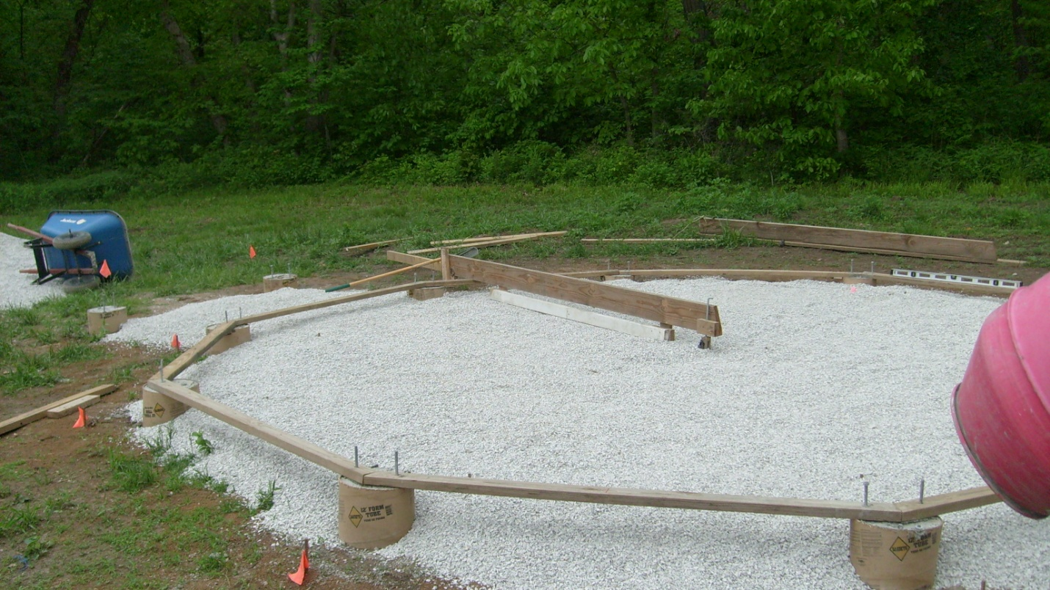

Place treated base board and level with ½” gravel

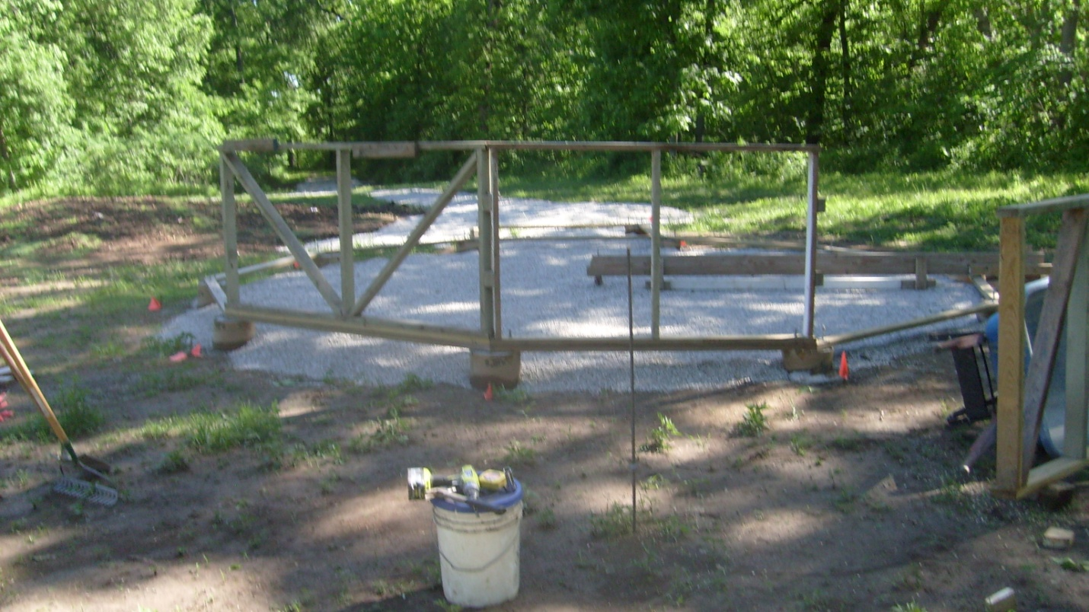

Bolt on framed, or finished knee wall sections