Solar Hot Water Collector
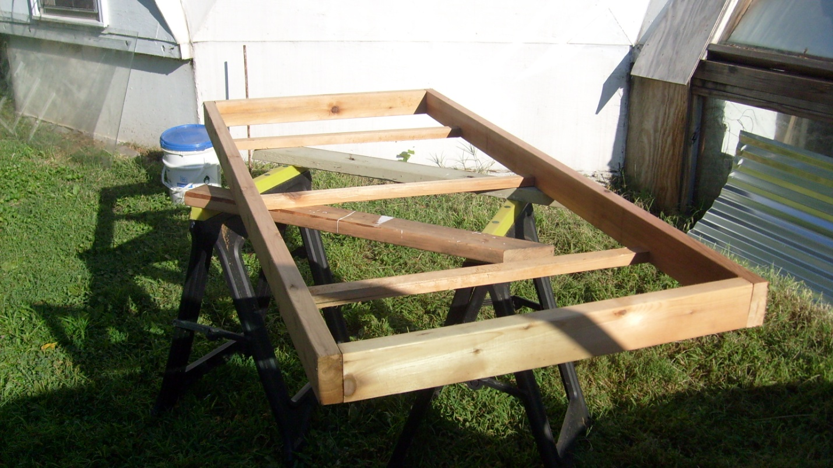
Frame from cedar 2x4s to reduce weight
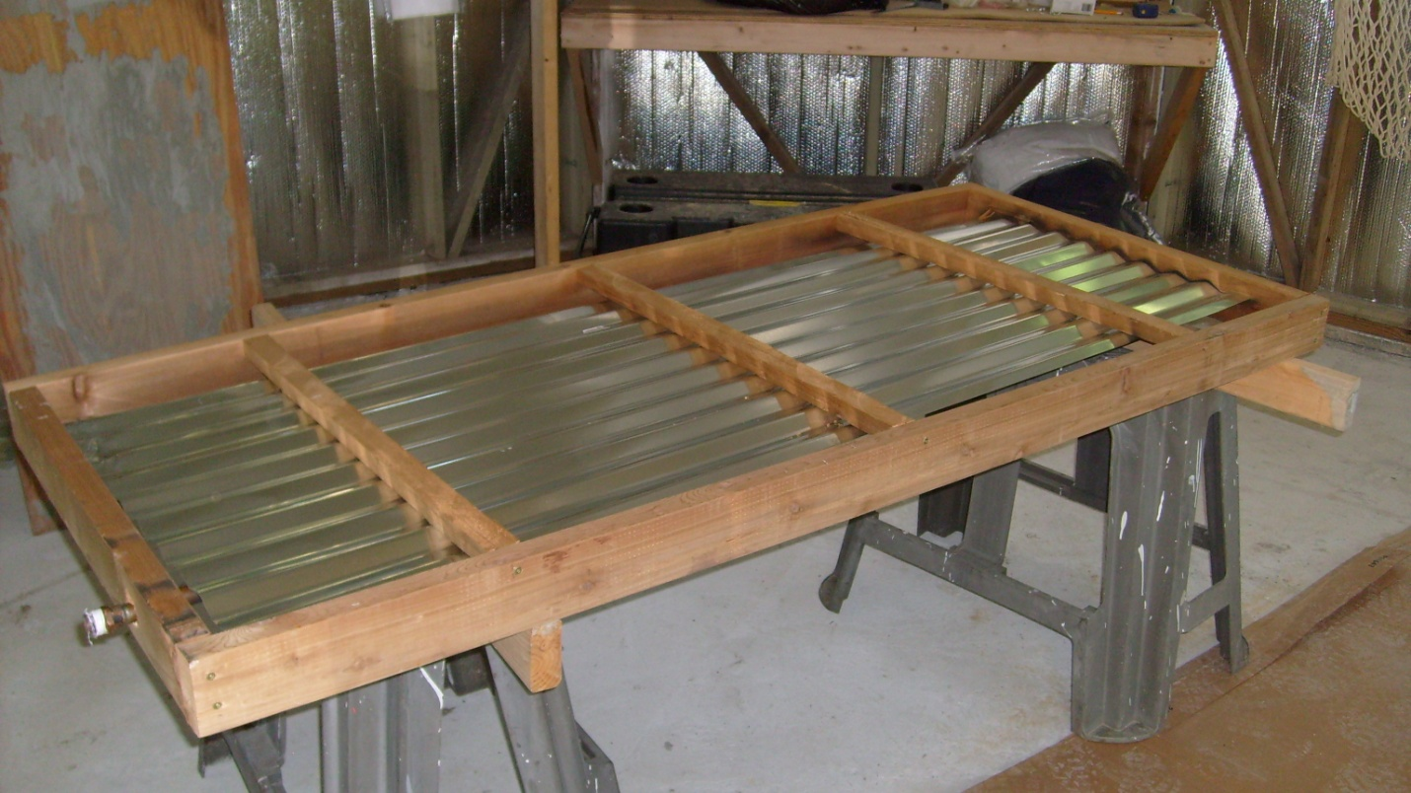
Use lightweight corregated roofing for energy absorber
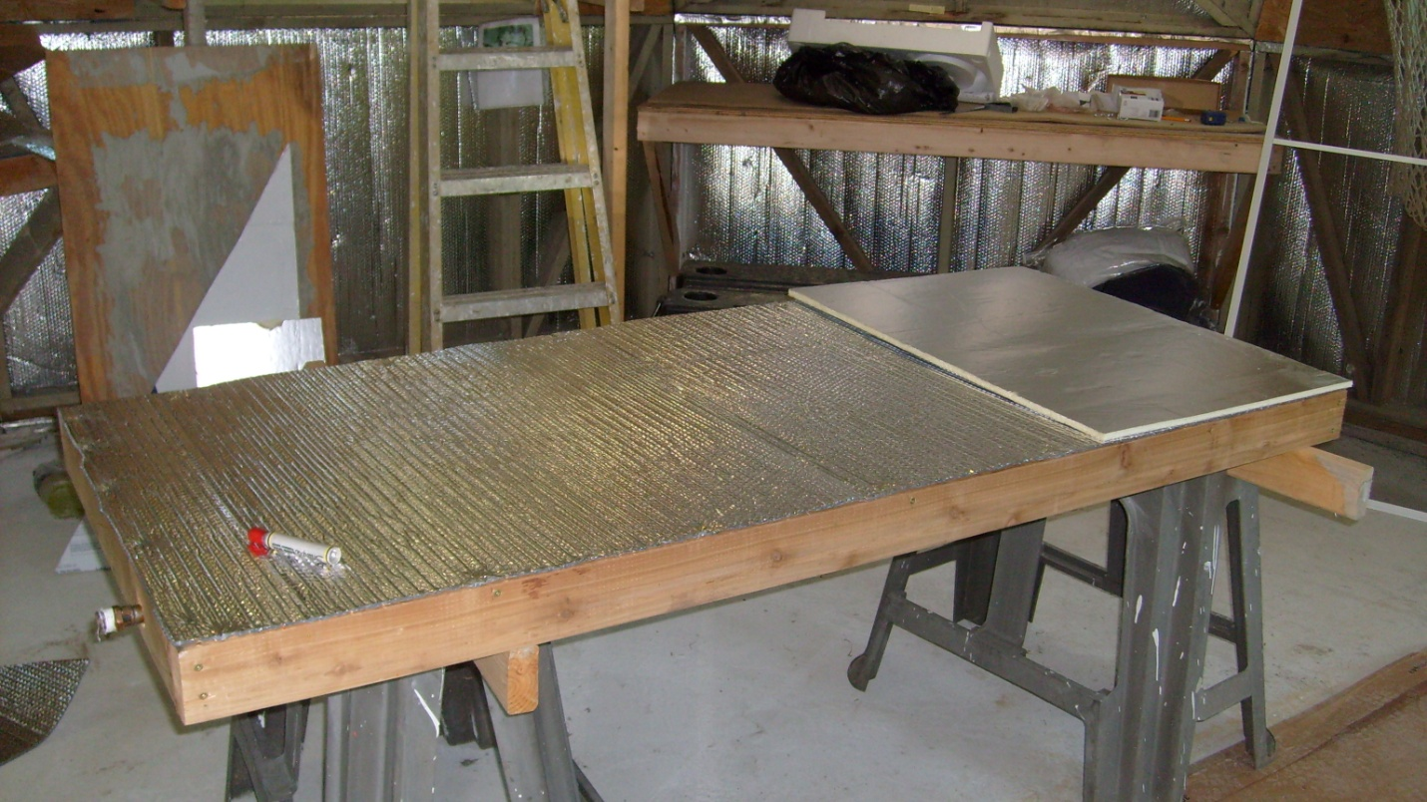
Double layer insulation Reflectix & board insulation
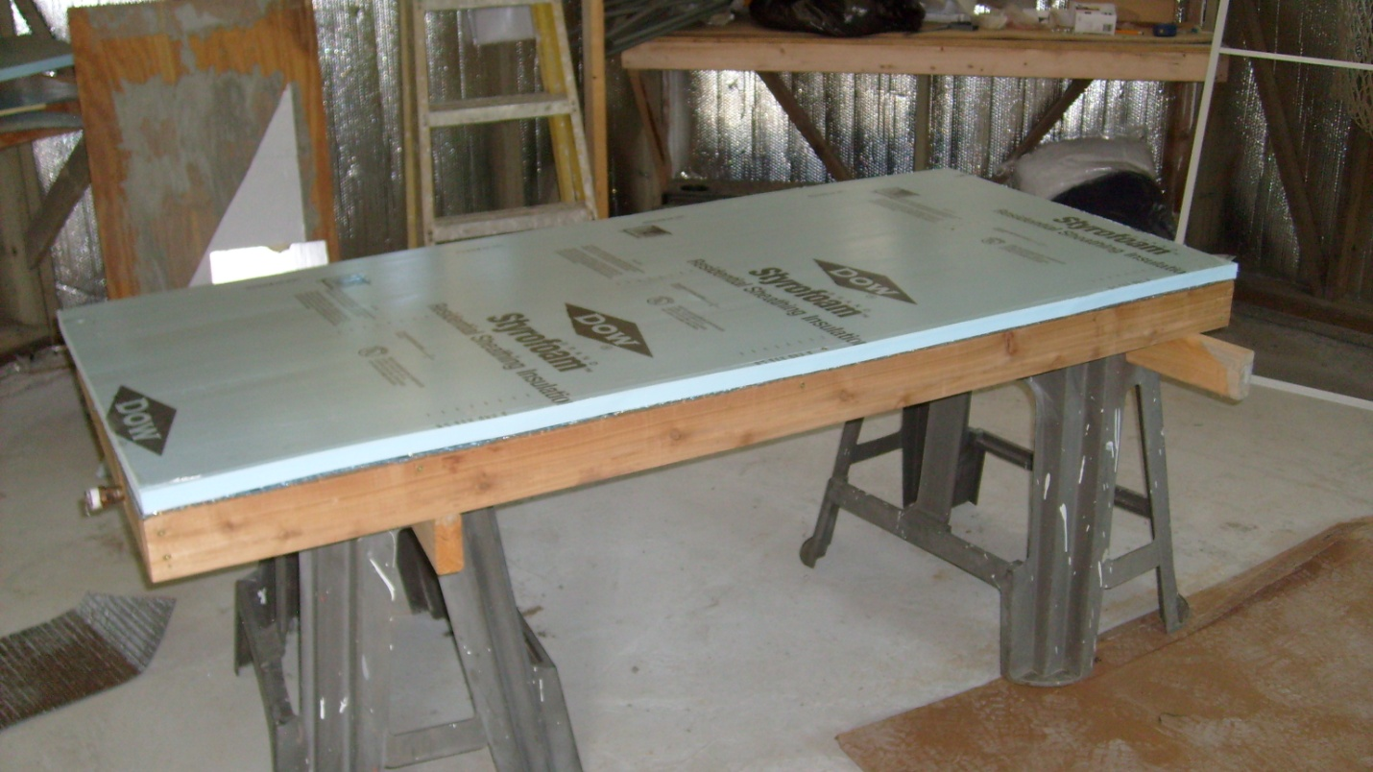
Board insulation on bottom of panel
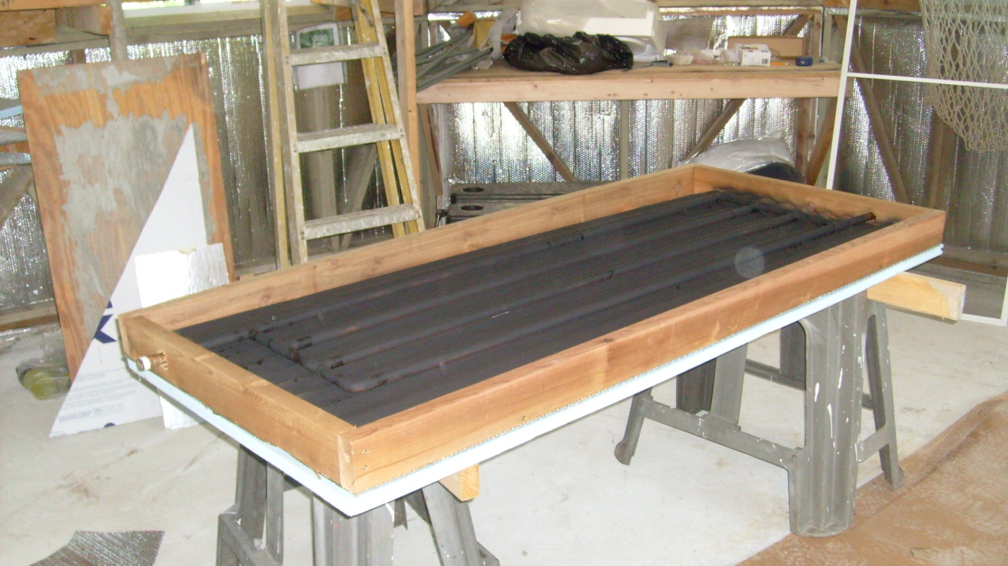
Use copper tubing painted black as energy transfer mode
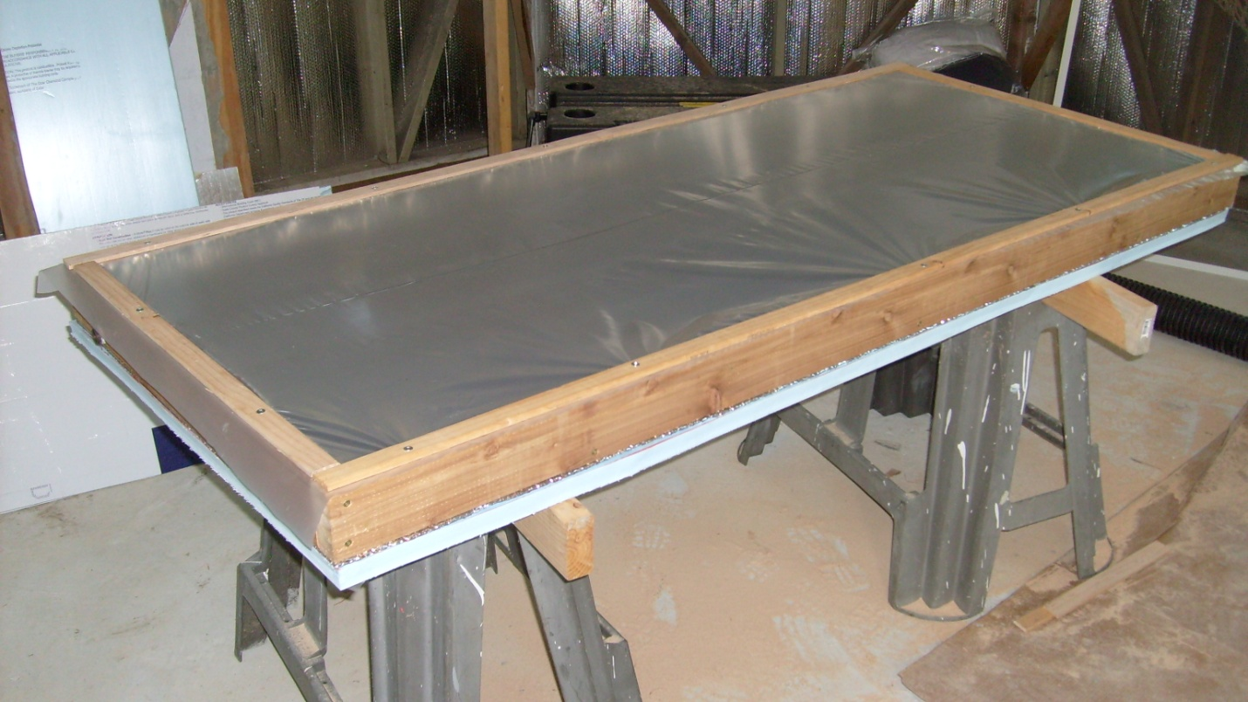
Cover panel in 6 mil poly
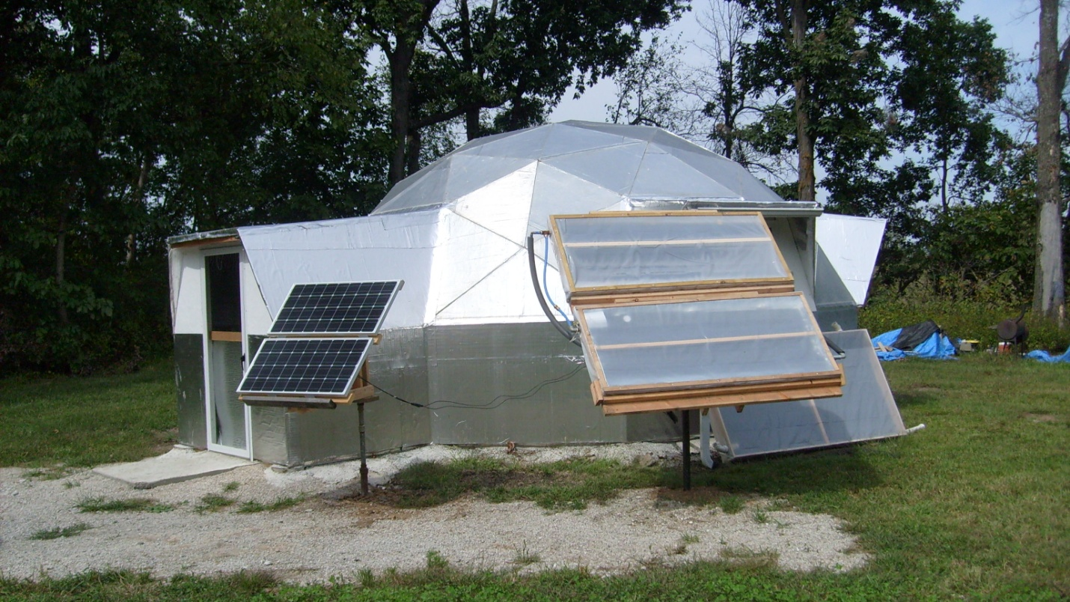
Double hot water solar collector on tracker system

