Solar Radiant Heat Floor System
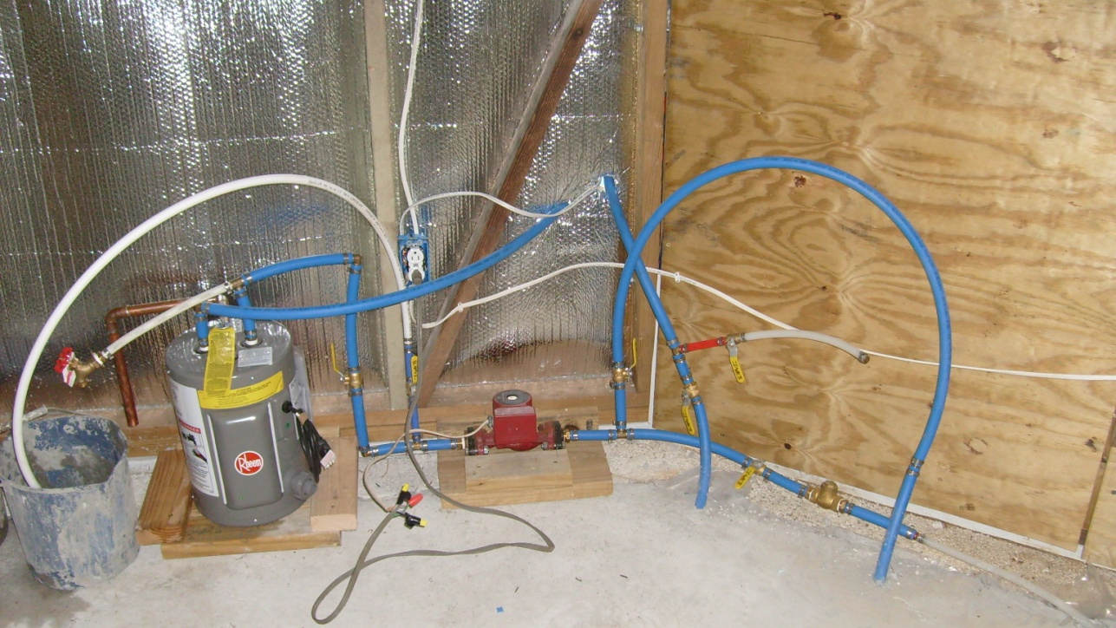
System contains small drain back tank, with 3 speed 1/25 hp pump, water source with one way valve, and tubes going into slab. The pump has an on/off switch, plus a temperature range switch located in the outside solar collectors.
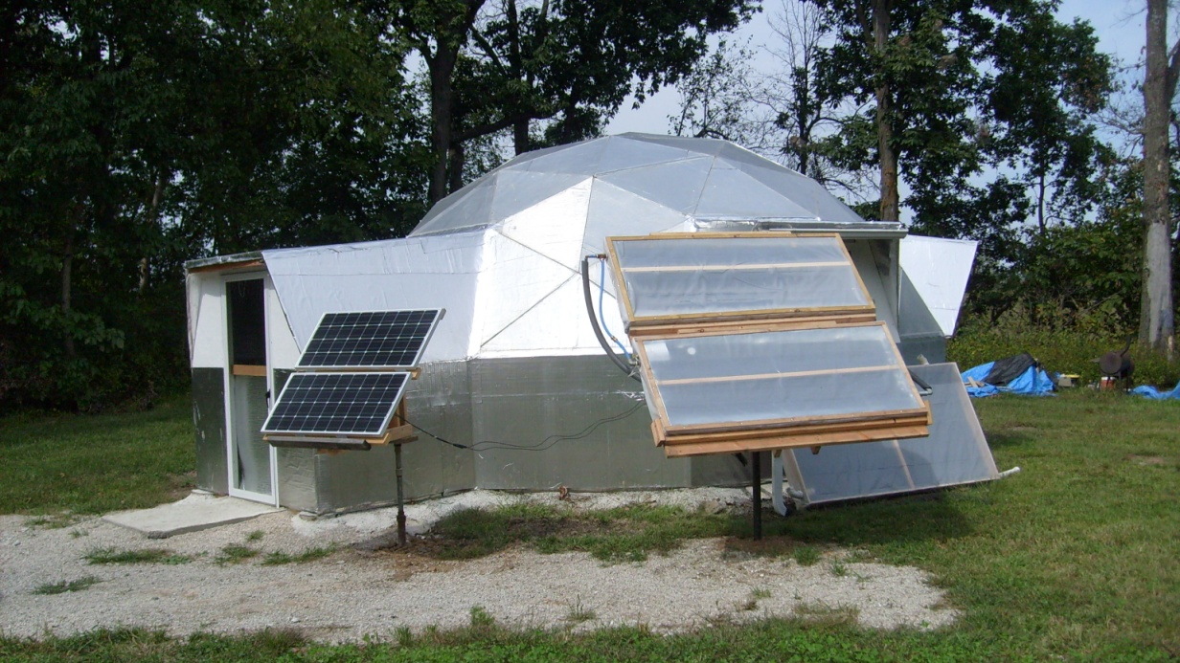
The system has a double panel tracking solar collector to charge battery bank, which is tied to inverter, which supplies 110 volt power to lights, fan, battery chargers, and pump. Next to structure is also a hot air collector to supply heated air to building. The double solar hot water panels are on a solar tracking frame which was made from a satellite tracker.

